200888 NYSERDA O&R Challenge

Smarter Inverter and Advanced Distribution Management System (ADMS) Integration Project

Supported by

**New York State Energy Research and Development Agency (NYSERDA)**

**PON 4128 - NYSERDA Agreement No: 149165**

**Report A**

**“Power Hardware-in-the-Loop Experimental   
Smart Inverter Testing Environment at RPI”**

**Rensselaer Polytechnic Institute**

**110 8th Street**

**Troy, NY 12180-3590**

**September 25, 2022**

Authors:

**Hao Chang, Prof. Luigi Vanfretti**

**ALSET Lab,**

**Electrical, Computer and Systems Engineering Department**

RPI Principal Investigator/Project Manager: Luigi Vanfretti

Telephone: 518-276-2378, Email: vanfrl@rpi.edu

NYSERDA Project Manager

Michael Razanousky

SGS Project Manager

Yusef Orest

Table of Contents

**Introduction** **3**

**Power Hardware-in-the-Loop Experimental Test Setup Overview** **4**

**Equipment** **5**

Electrical Instruments 5

OP1400 Test Bench 5

OP8110 Power Amplifier 5

OP1480 Power Amplifier Panel 6

OP1490 Auxiliary Supplies and Safety 7

IT6006C-500 Amplifier Power Supply 8

TSD1000-15 DC power supply 9

SMA SHP 150-US-20 Inverter 10

PQ Meter 11

Autotransformer 11

Networking and Communication 12

Communication Overview 12

Ethernet Connection 13

RT-Simulation Setup 14

Consol PC 14

Opal-RT Simulator 15

**Lab Equipments Installation** **15**

Overall setup 15

Metering 26

**Bibliography - References** **29**

# Introduction

The main aim of this project was to test the functionalities of smart inverters and their integration to Smarter Grid Solutions’ Distributed Energy Resource Management System (DERMS) within RPI’s ALSET Lab facilities. The original plan involved obtaining an inverter from Borrego.

To minimize cost and safety, the original scope was to perform testing of the inverter’s controller board functionalities with existing lab facilities that were equipped to perform low-voltage Controller Hardware-in-the-Loop (CHIL) testing, which means that the power stage of the inverter would be disconnected and modeled in a real-time simulator. A schematic that illustrates the differences between real-time (RT) simulation, CHIL and power hardware-in-the loop (PHIL) simulation is shown below, while a table that compares the three different analysis methods is shown in the next page. While the RT simulation approach is based entirely on simulation models, the other two methods involve hardware components, in the case of CHIL it only involves the controller boards (low-voltage low-power functionalities) and in the PHIL case it involves the use of a bi-directional power amplifier capable of “emulating” the point of connection to the actual hardware inverter. This implies that there is an increase in complexity when going from RT, to CHIL to PHIL, ***with the PHIL approach being increasingly more complex than even operating a field installation due to the care that must be taken when operating a bi-directional power amplifier (and complexity of the amplifier itself).***

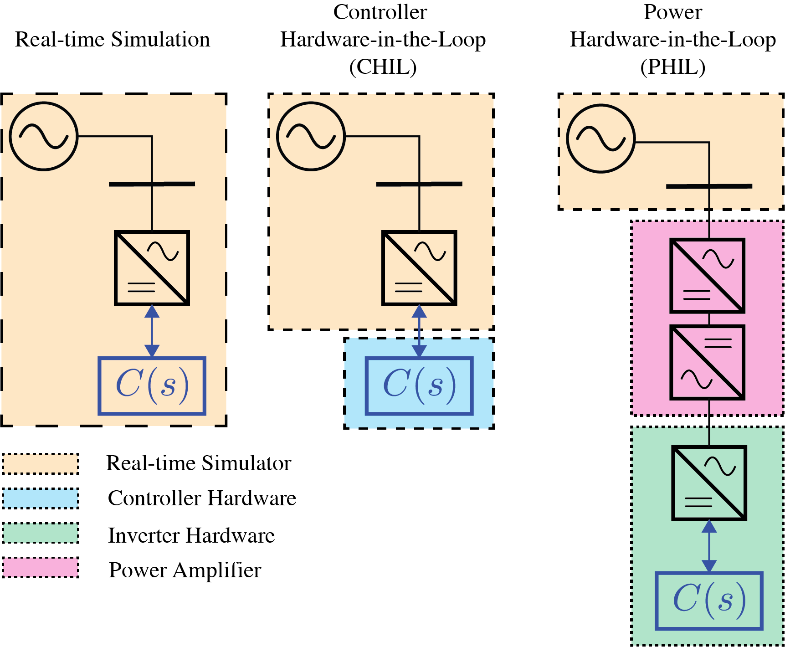

|  | **RT** | **CHIL** | **PHIL** | **Field Instal.** |
| --- | --- | --- | --- | --- |
| Cost | + | + | **+++** | +++ |
| Fidelity | +/- | + | **++** | +++ |
| Complexity | + | ++ | **++++** | +++ |
| Coverage | + | ++ | **++** | +++ |

Thus, the original plan of the project considered a first phase where the CHIL approach would be used, and after testing using this approach, it would be determined if it was sufficient if other testing would be required. During the initial phase of the project, the CPS SCH 100/125kTL-DO/US-600 from CHINT was being considered for use in the project testing and field installations. SGS and RPI worked together with Borrego and CHINT in assessing if the CPS SCH 100/125kTL-DO/US-600 inverter could undergo CHIL testing, while all efforts were made by the SGS and RPI team, and multiple meetings with CHINT were conducted, the manufacturer refused to aid in the testing using CHIL approach. Moreover, RPI was informed on ***April 8th, 2021,*** that the type of inverter would not be procured from CHINT, but from a different manufacturer (see Appendix with email from Chris Linn, formerly at SGS). Unfortunately, this supplier (SMA), was also not willing to facilitate CHIL testing.

***Consequently, RPI started evaluating options in March 2021 on what type of facility would need to be developed to conduct PHIL*** tests, as multiple pieces of equipment would need to be purchased and staff would need to be trained to comply with safety regulations.

After an assessment of options for PHIL testing was conducted, ***starting May 2021,*** RPI had to start the development of a PHIL test bed. The purchasing process for the numerous electrical power, metering, computing and communication equipment described in this report was initiated also in May 2021. Due to the substantial costs of bi-directional power amplifiers (the cost of these increases with their nameplate capacity), it was agreed that a 15 kW bi-directional power amplifier would be acceptable to test the inverter at 12% of its nameplate capacity. However, this was done under the assumption that the capacity would be 125 kW, and ***the information on what type of specific inverter RPI would be tested was not available until delivery of the SMA SUNNY HIGHPOWER PEAK 150-US in July 2021.*** While this has not ultimately affected the potential to conduct tests, it does imply that the rating of the inverter at which the tests will be conducted would be at a maximum of 10% of nameplate capacity.

Electrical design was conducted with the pro-bono support of Mr. Joseph Dengel (a former RPI alumni with vast experience in electrical installations in terrestrial and marine applications), which later was reviewed and approved by RPI’s facilities personnel which also aided in the installation, making sure that the facility would satisfy RPI’s safety requirements, with **the main electrical work being completed by mid-September 2021**.

The procurement process to acquire the amplifier started ***in May 2021***, in this process, six different manufacturers were contacted. Due to cost and forecasted supply availability from the vendors, Opal-RT’s OP1400 PHIL Test Bench at a cost of $82,500 was selected and paperwork for the procurement approval was sent to RPI’s procurement team on **6/5/2021**. Note that to cover these costs, the full budget for equipment from NYSERDA was used ($45,000) while the remainder was obtained through cost share from NYSTAR/CFES. In addition, due to costs, this required additional approvals and paperwork, received approval by the former President of RPI only by ***6/28/2021.*** While the supplier, Opal-RT, offered a delivery data of 8 weeks, this implied that the main component of the facility (the bi-directional power amplifier) would have been delivered by early September 2021, this underwent major delays due to a design flaw identified by the manufacturer and the supply-chain shortage affecting world-wide manufacturing (see the appendix with the communications with the vendor). The Site Acceptance Test and training for the bi-directional amplifier was finally conducted at RPI’s facility on ***26-28 July, 2021***.

After the training, the metering for the facility was finalized, and testing of the overall facility was started. After several trials, ***the RPI team was able to conduct fully operational tests using PHIL on September 15, 2021, with Rachel Cornick of Smarter Grid Solutions witnessing the tests and full demonstration of the capabilities of the lab.*** Since then, the RPI team has been working with SGS to address communications aspects between the DERMS system and the inverter, and how to conduct the functionality testing of the inverter in the coming months.

In the remainder of this document, we document each of the components of the laboratory facility and show how the installation has been completed as witnessed by SGS (virtually and in person) as of September 25, 2022. It is worth noting that due to the changes experienced due to issues with Borrego and Chint, restrictions placed at RPI related to the COVID-19 pandemic, and the delays experience by Opal-RT to deliver the bi-directional amplifier, the completion of this facility was an extremely complex and challenging task. Having made tremendous efforts by the faculty and staff at RPI, we hope that the facility can be exploited in other projects with SGS, NYSERDA and NY State utilities to fully take advantage of this advanced capabilities.

# Power Hardware-in-the-Loop Experimental Test Bed Overview

The above schematic and figures illustrated the following equipments:

1. 30 A Fuse box and Switch
2. Nexus Meter
3. TDS-1000-15 DC power supply
4. SMA 150kW Smart Inverter
5. Autotransformer
6. 3-poles double throw Switch
7. OP1400 Power Amplifier and DC Power Supply for the Amplifier
8. 3-poles double throw Switch
9. 30 A Fuse box and Switch

# Equipment

In this section, all the essential equipment for this project will be introduced.

## Electrical Instruments

### OP1400 Test Bench

#### OP8110 Power Amplifier

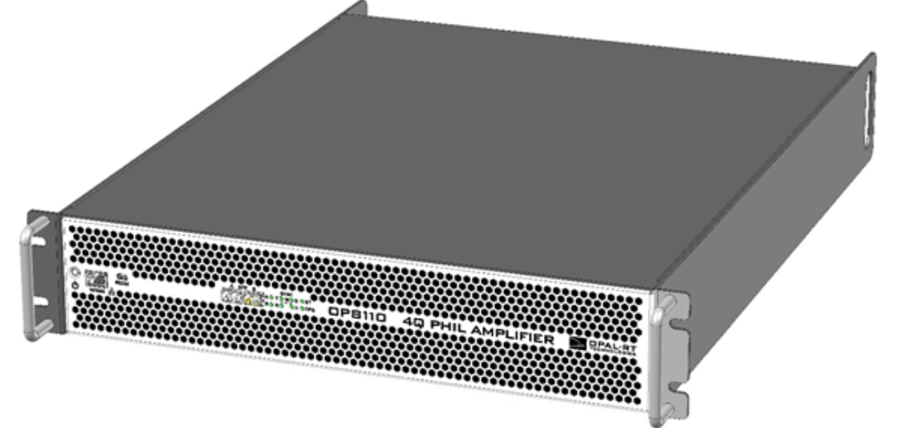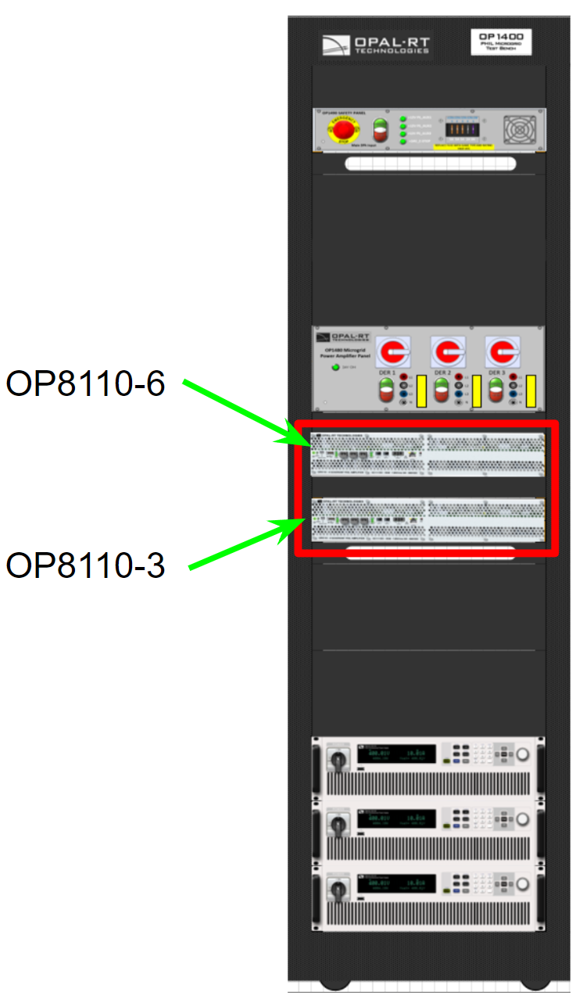

*Figure 1: OP1400 Power Amplifier*

The OP1400 4-Quadrant power amplifier has 6 amplification units of 5kW each. For this project the amplifier is emulating the power grid that the inverter is connected to. Since this amplifier is a 4-quadrant amplifier, we are able to use it to sink the power from the PV inverter to be tested. In operation, the amplifiers will generate 277/480Vrms 3 phase voltage to emulate normal grid conditions. The output voltage and frequency from the amplifier is configurable, so we are able to complete Low/High frequency ride through and Low/High Voltage ride through tests for the inverter.

#### OP1480 Power Amplifier Panel

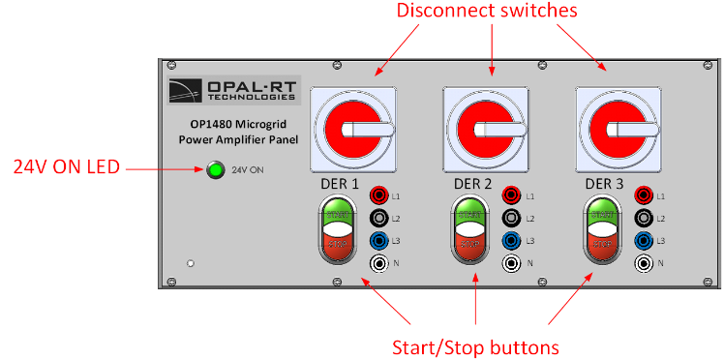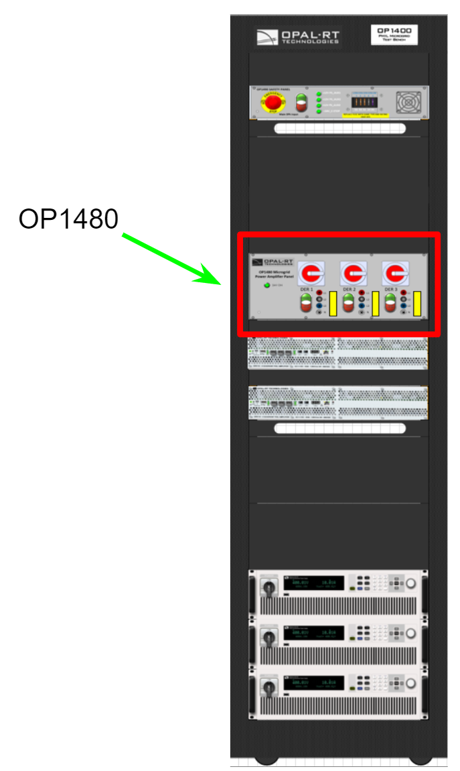

*Figure 2: OP1480 Power Amplifier Panel*

The OP1480(DER) allows us to safely connect and disconnect OP8110 amplifiers. It features triple safety protections for each phase. The Start/Stop button on the panel is able to open or close the contactors to isolate the inverter from the test bench. Three Disconnect switches(rotational) are also able to connect or disconnect the inverter. All lines are protected by three 25A fuses to protect the amplifier in case there is any short circuit fault. This equipment is important for the safety of the personnel and the test bench equipment.

#### OP1490 Auxiliary Supplies and Safety

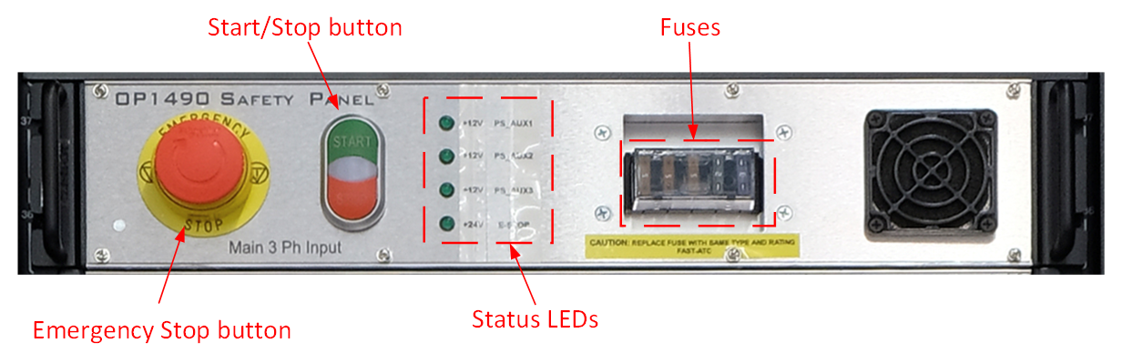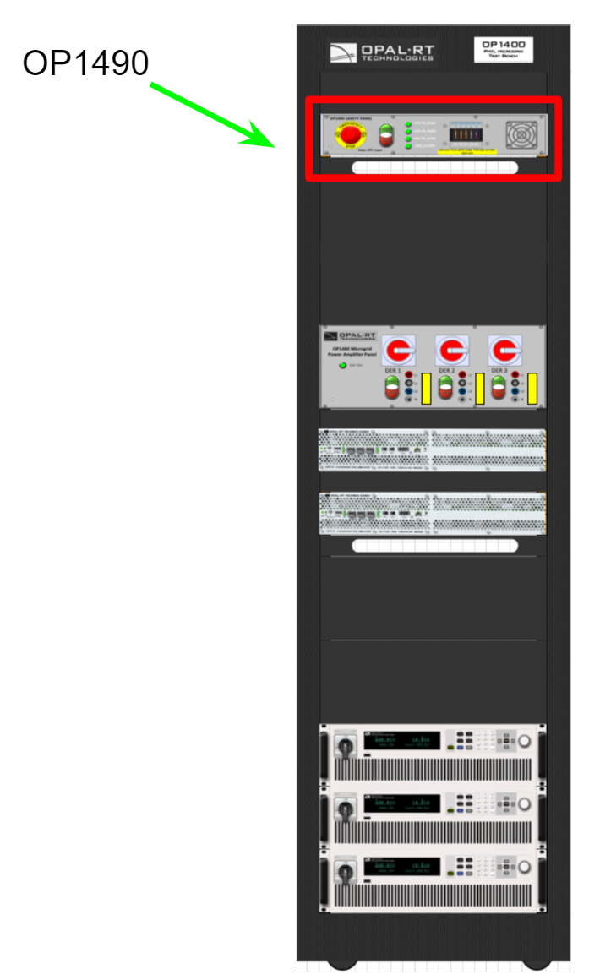

*Figure 3: OP1490 Auxiliary Supplies and Safety*

The OP1490 boxes provide 12V auxiliary supplies for the OP8110 amplifiers. The Start/Stop button can activate or deactivate the 3 phase 480V supply to the DC power supplies. “The emergency stop button allows you to quickly secure the test bench in urgent situations. It is hard wired to an emergency stop loop that energizes the contactors inside the OP 1460/1480 boxes and inside the PDU. When the user pushes on the emergency stop button, all these contactors become unsupplied and this effectively isolates the test bench's power path (excluding monophasic power bars) from all possible sources of electrical energy. The button will remain depressed once it has been pushed down, the user must then rotate the button clockwise to reset the emergency stop loop. The emergency stop button can be secured with a padlock if desired.”

#### IT6006C-500 Amplifier Power Supply

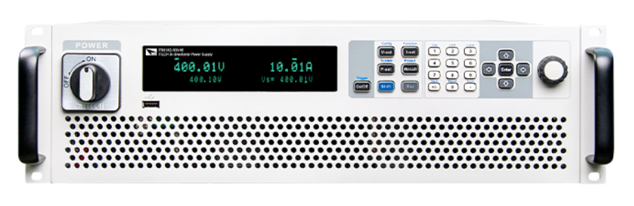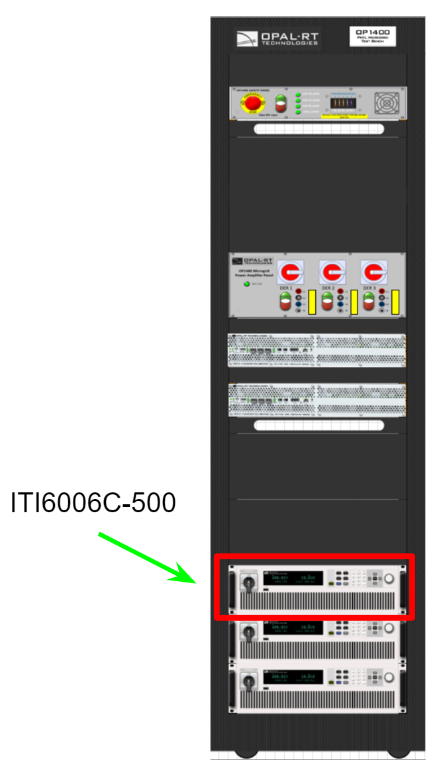

*Figure 4: IT60006C-500 Amplifier Power Supply*

The OP1400 test benches are equipped with ITECH IT6000C series Bidirectional DC Power Supplies. These power supplies provide the OP8110 4-Quadrant amplifiers with a constant 500V DC input voltage and allow the amplifiers to consume or to feed back power from/to the 3 phase mains input. The amount of power supply units and the power ratings of each unit have been especially chosen by Opal-RT so that the test bench can deliver its full performance.

### TSD1000-15 DC power supply

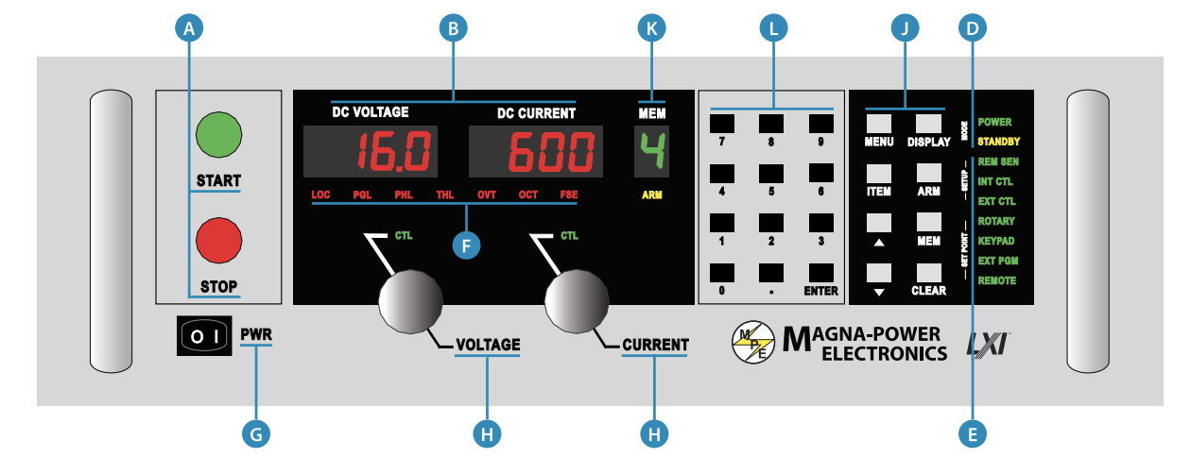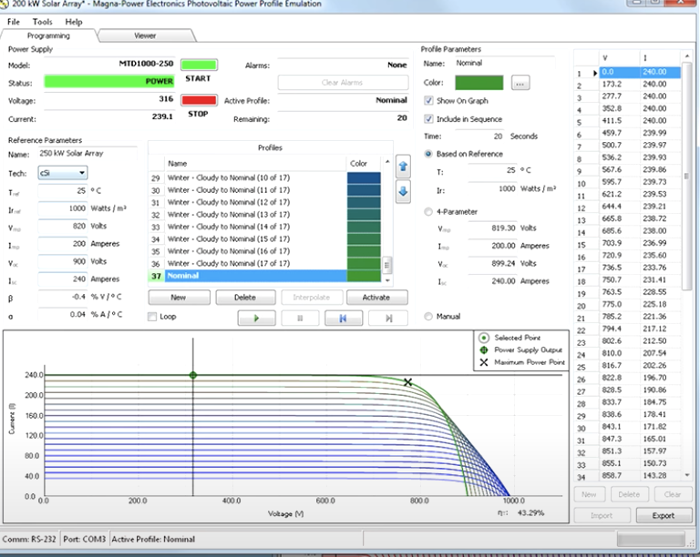

*Figure 5: TSD 1000-15 DC Power Supply*

MagnaDC programmable DC power supplies feature programmable voltage, current, and protection settings along with high accuracy measurements. All MagnaDC programmable DC power supplies utilize high-frequency IGBT-based power processing in current-fed topology. This topology adds an additional stage over the conventional voltage-fed topology for enhanced control and system protection, ensuring that even under a fault condition, the power supply will self-protect. Due to the self-protecting characteristics of this topology, the possibility of fast rising current spikes and magnetic core saturation is eliminated. The Photovoltaic Power Profile Emulation (PPPE) software automatically calculates solar array voltage and current profiles based on user-defined parameters. These profiles can be sequentially sent to a Magna-Power Electronics power supply, which will emulate defined characteristics. We can define a limitless number of profiles to be emulated and sequenced over a given time period to evaluate the performance of the inverter.

### SMA SHP 150-US-20 Inverter

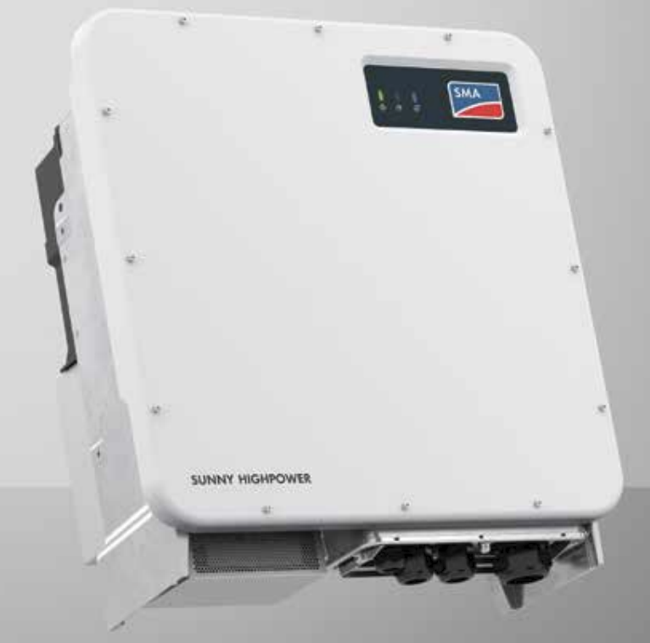

*Figure 6: SMA SHP 150-US-20 Inverter*

The SMA SHP 150-US-20 inverter is the main testing object of this experiment setup. This inverter is able to convert the DC generated by the solar panel to AC up to 150kW. The inverter is able to operate in different modes such as fixed power mode, Volt/Var mode, Frequency-watt mode etc. With the other peripherals mentioned in the previous sections, this test bench is able to validate that the inverter will work as expected when deployed in the field.

### PQ Meter

### 

*Figure 7: PQ Meters*

In our setup we have two kinds of power quality(PQ) meters, Nexus 1500+ and SEL-735. They are connected to each section of the system to get necessary voltage, current real power, reactive power etc. reading for the experiments. With the reading from the meters we can verify the installation.

### Autotransformer

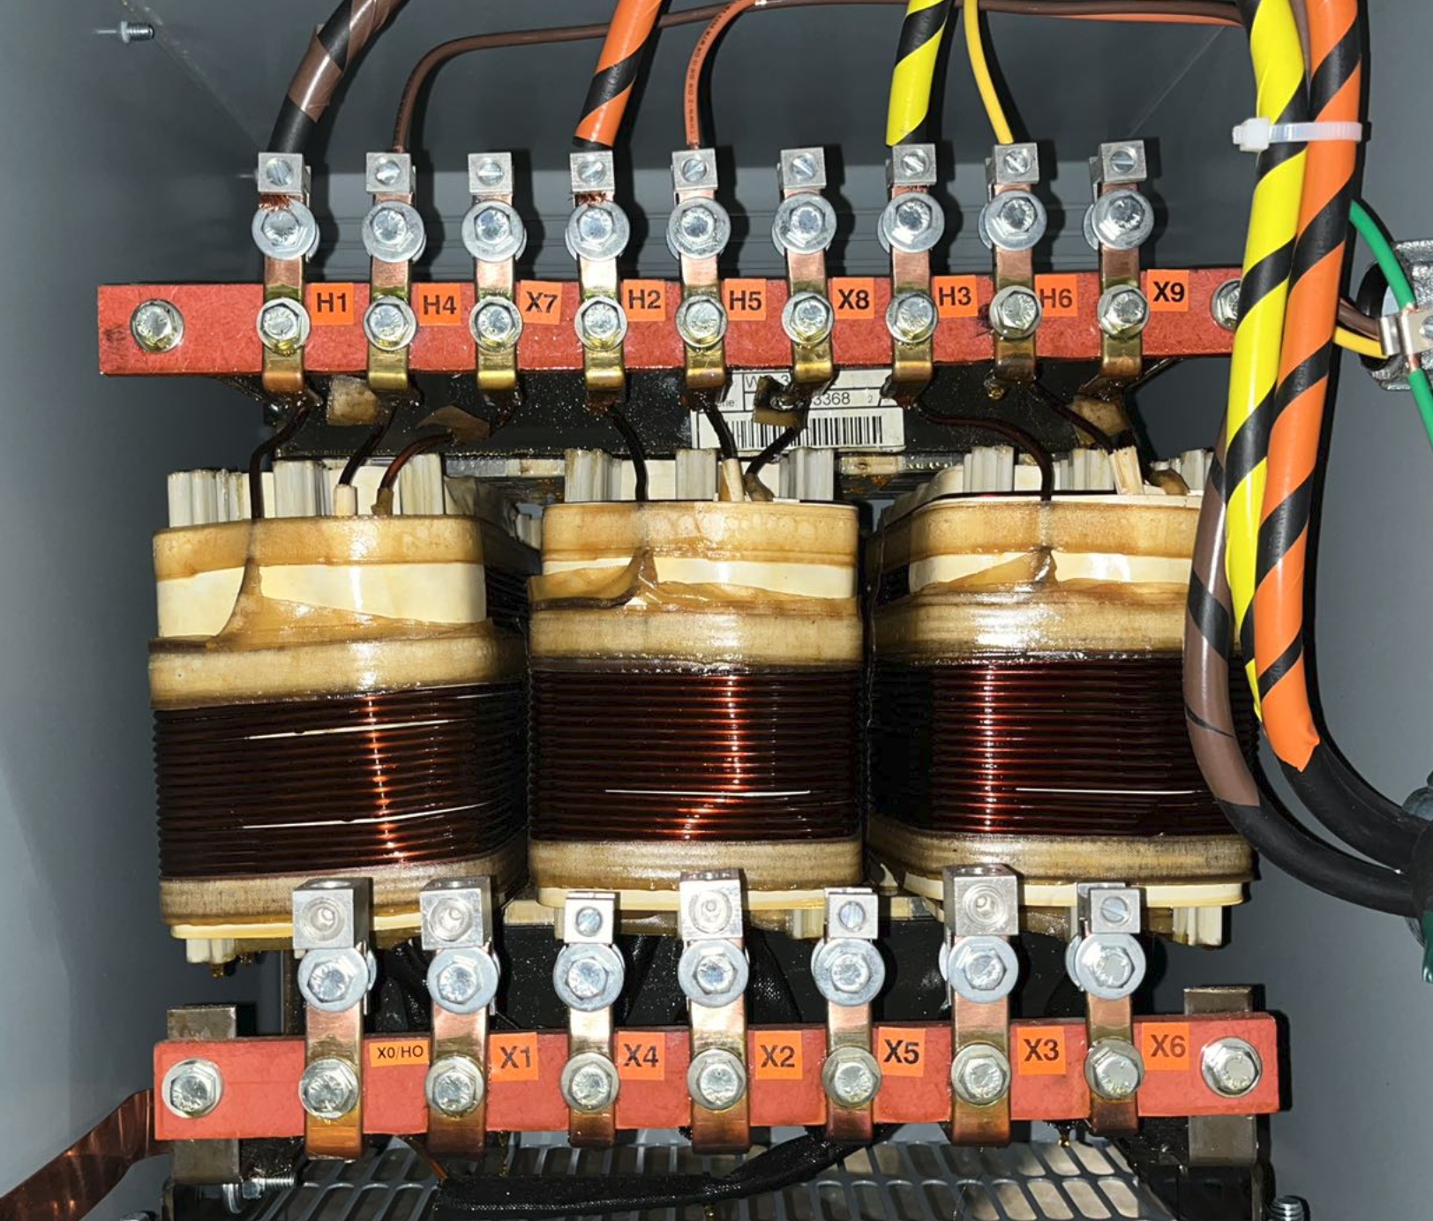

*Figure 8: AUT-MIT-114 Autotransformer*

The inverter we need to conduct experiments on has a voltage rating of 600V L-L(346V L-N)on the AC side. The power amplifier that is emulating the AC side grid behavior only has voltage rating up to 240L-N. Thus we need the auto transformer in the middle to step up the amplifier output to match the inverter’s voltage rating.

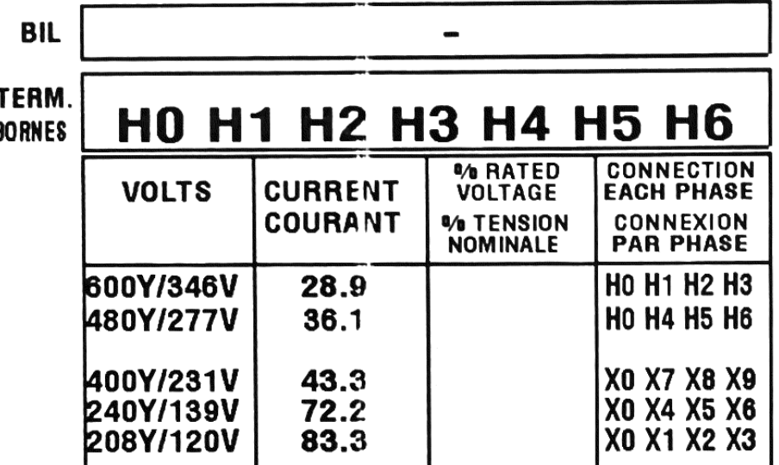

*Figure 9: Autotransformer specification*

The transformer has 4 different low side tabs for us to connect to match the experiment's requirements and equipment power ratings.

## Networking and Communication

### Communication Overview

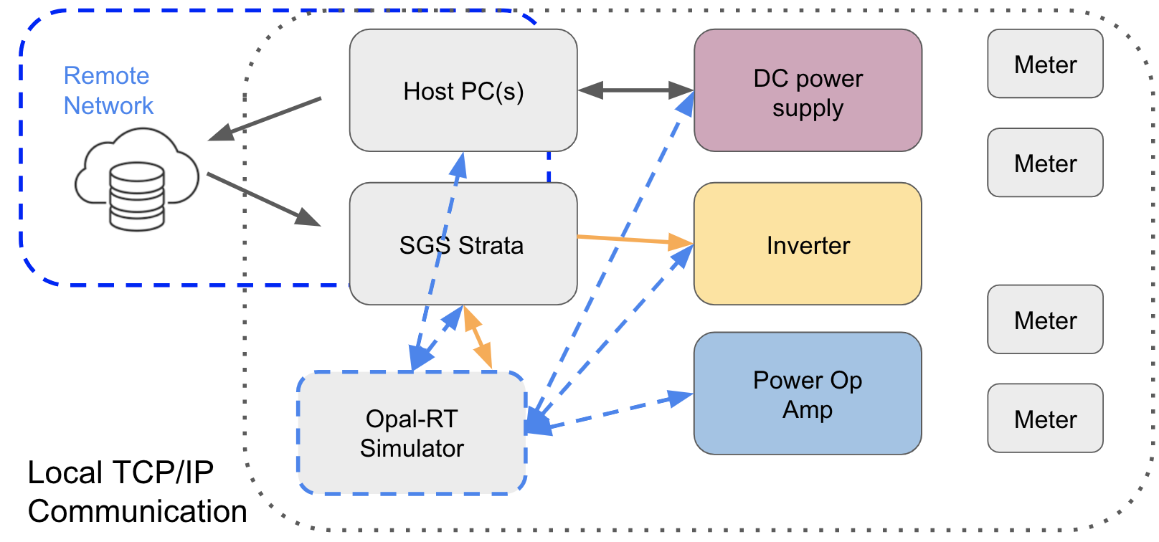

*Figure 10: Network Topology*

The above block diagram summarizes the communication structure of our inverter test bench setup. The network is divided into two separate regions: Local TCP/IP network and Remote network. On the remote network, we can access the SGS strata and Host PC(s) remotely over the Internet with remote software like Teamviewer, Anydesk, JumpDesktop, etc. The orange arrow stands for ModBus protocol. The blue dashed arrow indicates that UDP connection is used to exchange data. The blue arrows defined the communication controlled by the hardware.

### Ethernet Connection

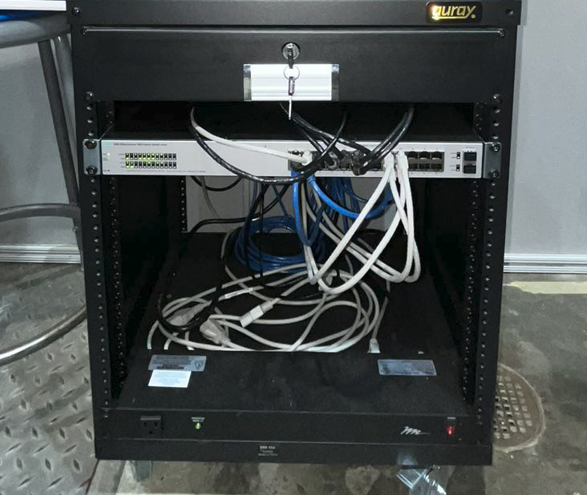

*Figure 11: Network switch*

All the devices are connected to a central switch via ethernet cables shown in the above figure.

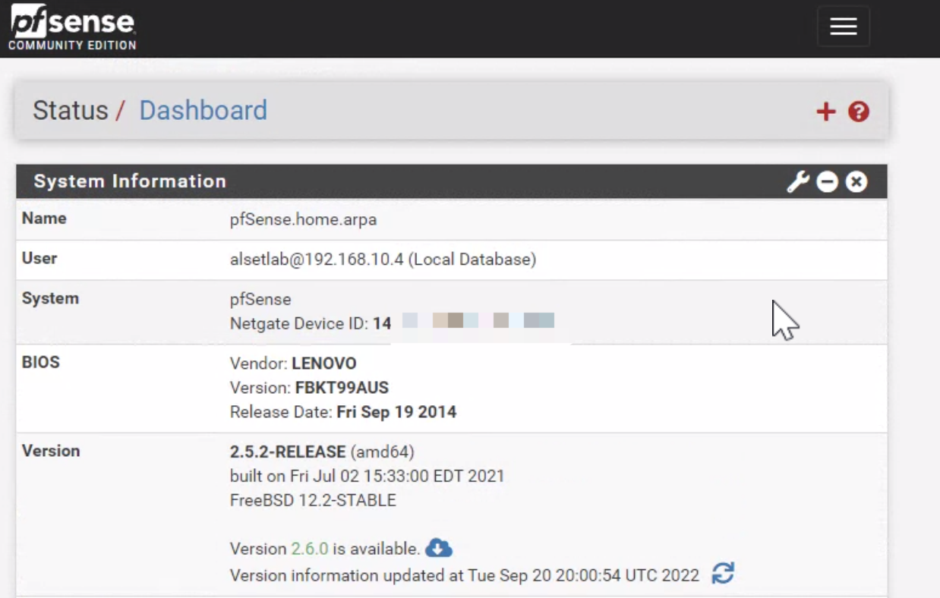

*Figure 12: pfSense Dashboard Control UI*

With the above software installed in the server, we can easily manage the device’s IP and MAC addresses.

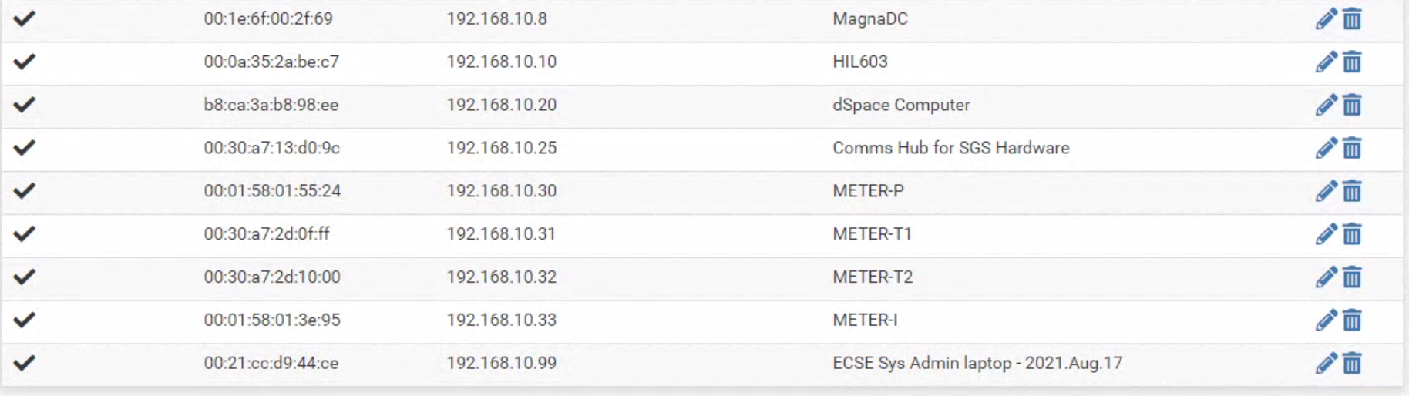

*Figure 13: pfSense MAC address IP allocation*

From the above figure, we can see that all the equipment in the lab that has an ethernet connection is connected and managed by this switch.

## RT-Simulation Setup

### Console PC

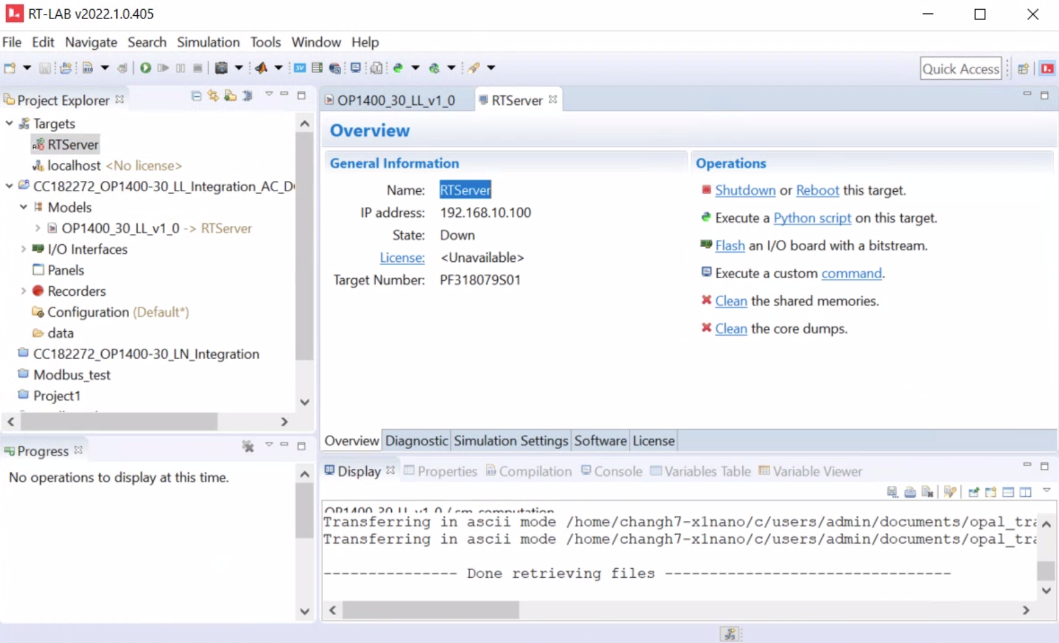

*Figure 14: Console PC RT-Lab UI*

From the host PC, we can access the RT simulator through RT-LAB to upload and run simulation models.

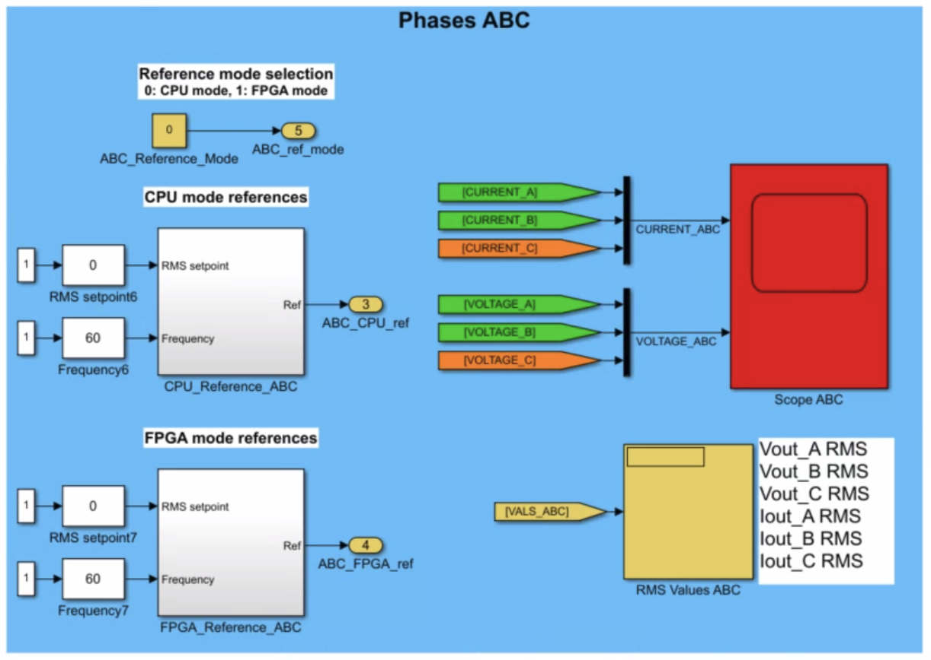

*Figure 15: Power Grid Control Panel in RT-Lab*

In the simulation model running on the Opal RT, we can change the voltage and frequency of the grid that we are trying to emulate. More detail will be given in the following sections.

### Opal-RT Simulator

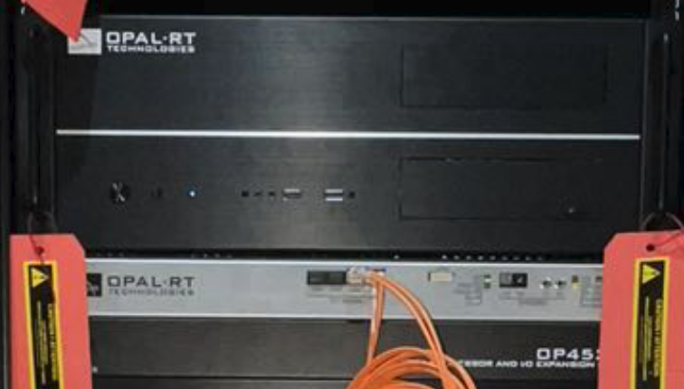

*Figure 16: Opal-RT Simulator*

The Opal-RT in the OP1400 test bench is able to simulate the grid model we want to investigate in real-time and communicate with a power amplifier with proprietary SFP interface(optical fiber).

# Lab Equipments Installation

## Overall setup

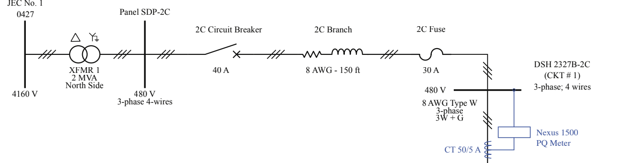

*Figure 17: Single Line Diagram*

The power configuration in the above figure describes the connection before the TDS-1000 DC power supply. For safe operation, a 40A circuit breaker is connected in the circuit to prevent any short fault to ground. The 30A fuse is protecting our DC power supply from extreme electrical failure to keep safe operation of all lab equipment.

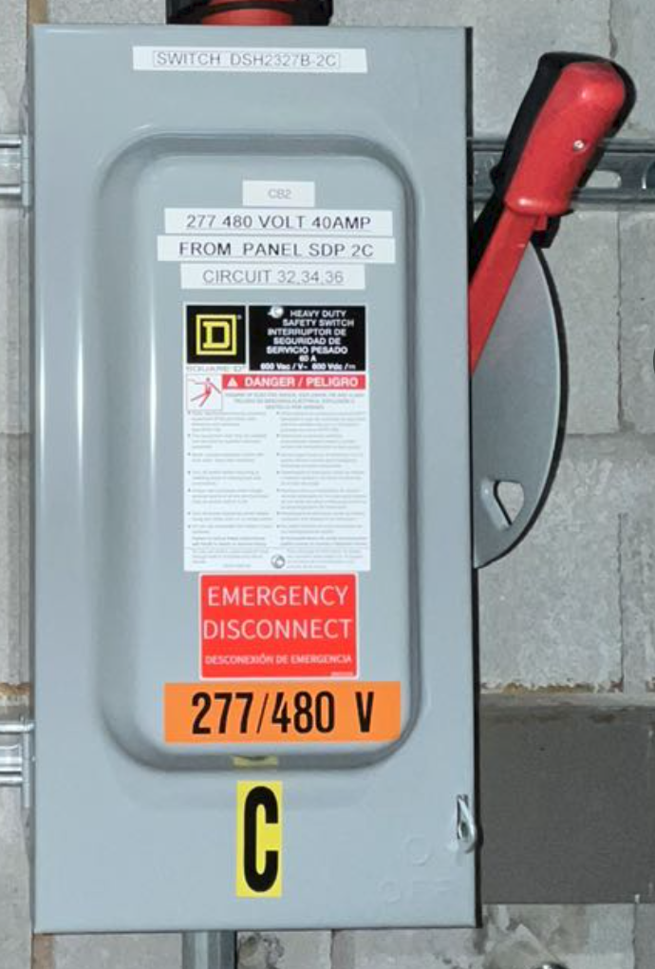

*Figure 18: Power Switch and Fuse Box*

The above switch can isolate the whole system from 480V L-L voltage on the one side. On the diagram the switch “C” is located at where the 30A fuse on the one line diagram. The current transformer is installed after the switch to monitor current flow through “C” or into the DC power supply. The current and voltage here are measured by one of the Nexus meters installed on the metering cabinet.

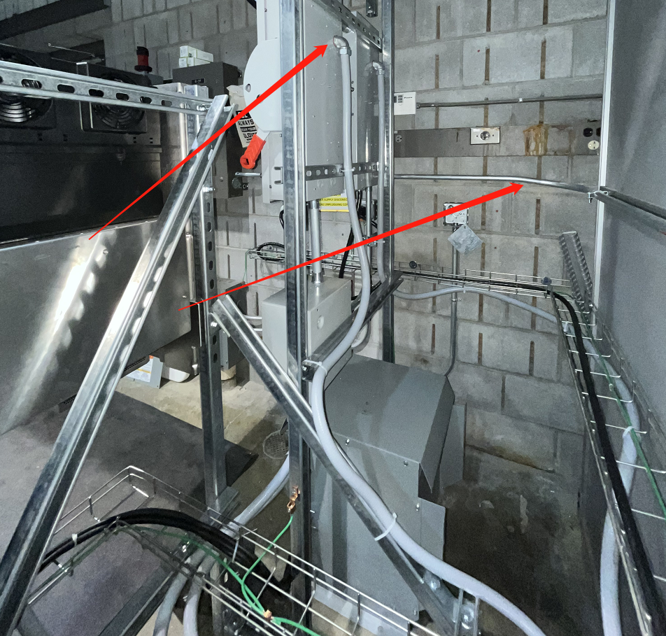

*Figure 19: Instruments Wiring*

The wirings are all contained inside metal and plastic pipes.

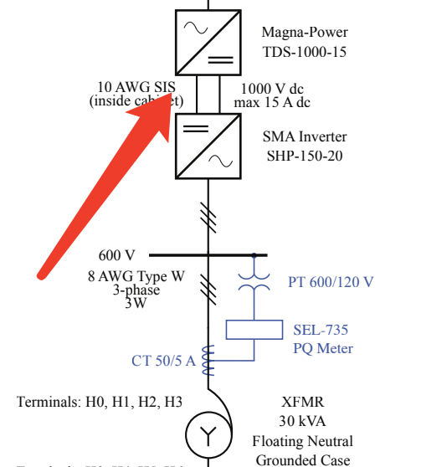

*Figure 20: Single Line Diagram*

The Magna-Power TSD-1000-15 DC power supply is connected to 480V L-L after the 30A fuse/switch.

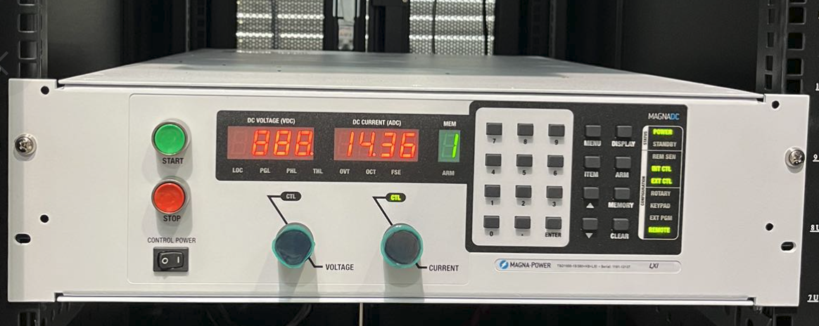

*Figure 21: DC Power Supply*

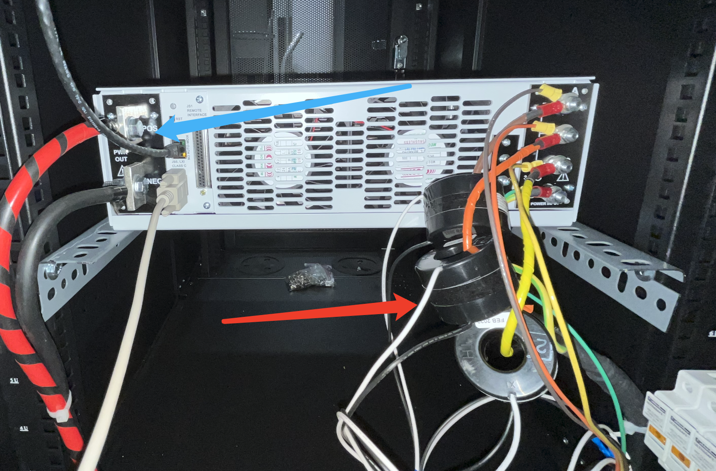

*Figure 22: DC Power Supply Wiring*

From the back of the power supply we can see the current transformer(Red Arrow) for measuring input 480V current and output Positive and Negative(Blue Arrow) DC power for the input of the inverter.

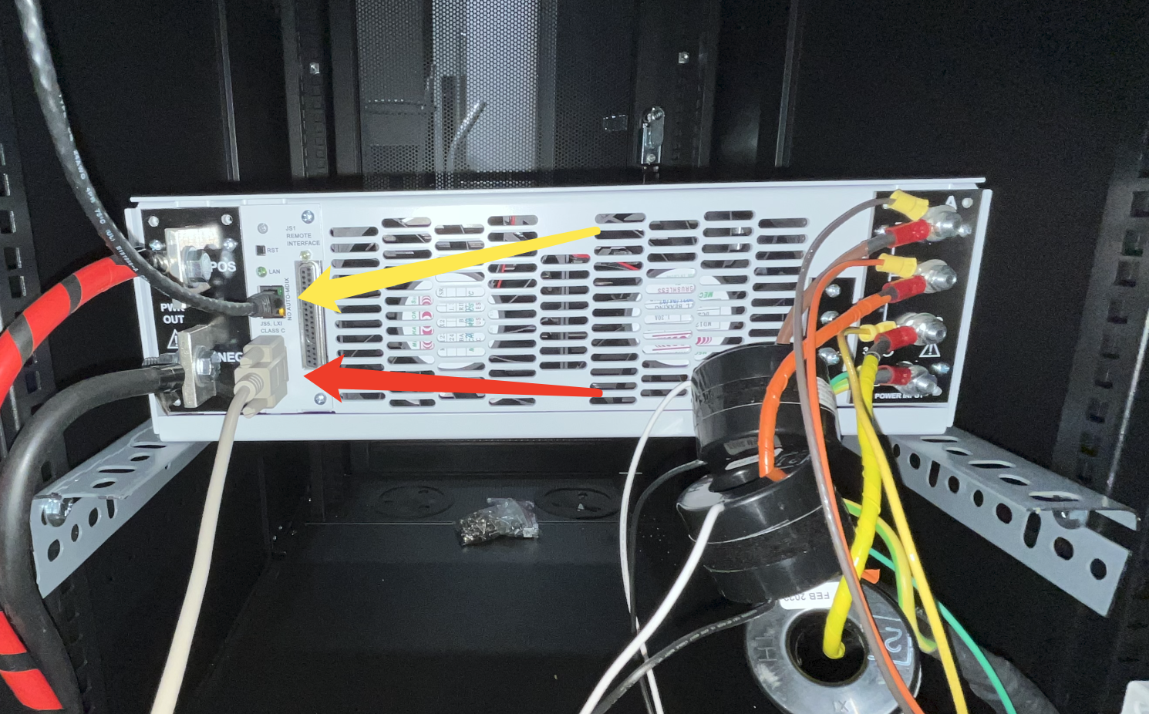

*Figure 23: DC Power Supply Wiring*

From the above figure, we can see the red arrow is pointing at the RS-232 serial input for the solar panel emulation software running on the host computer. The yellow arrow is pointing at the ethernet port that is connected to the central switch that allows us to control the DC power supply not only with the serial port but also over ethernet.

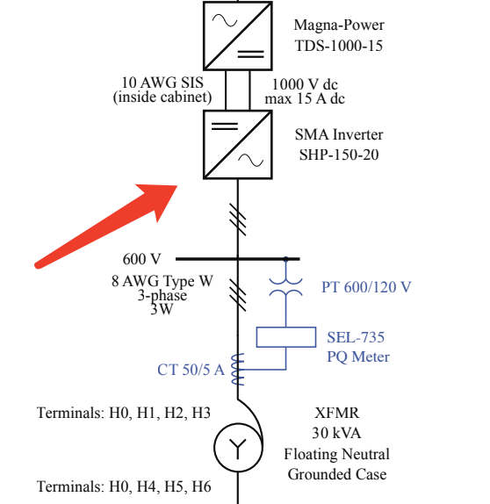

*Figure 24: Single Line Diagram*

From the above schematic the DC power supply is connected to SMA SHP-150-20 inverter.

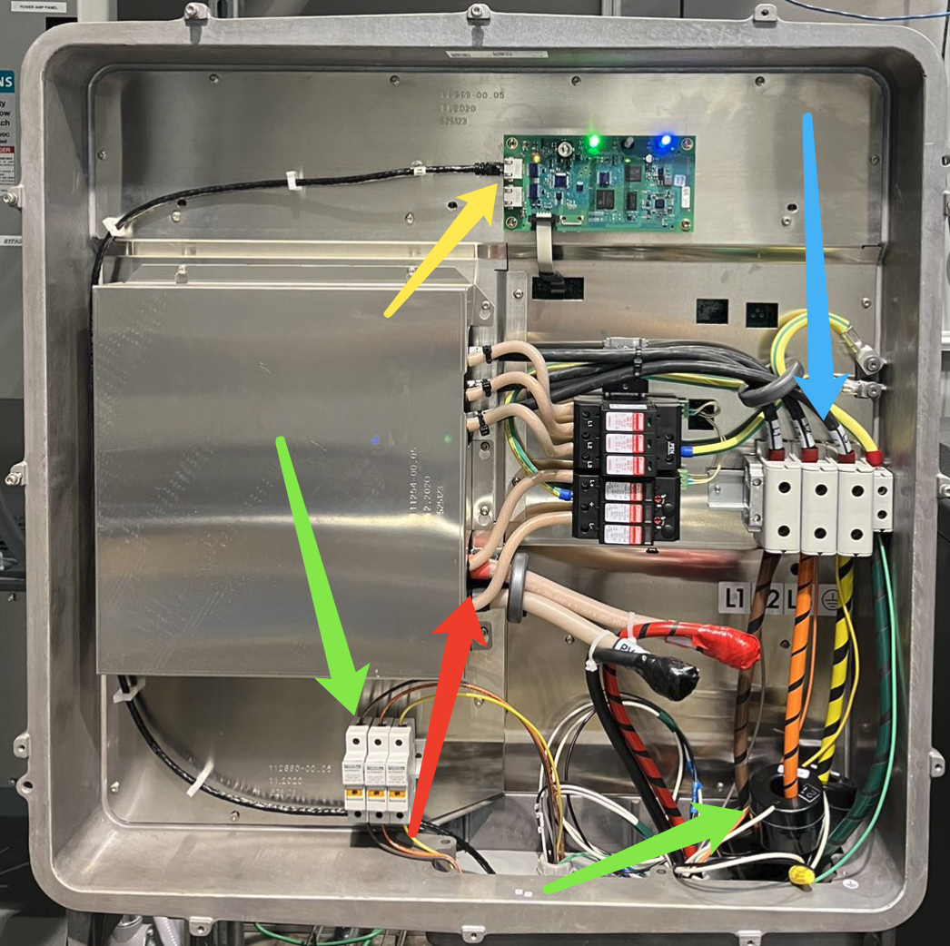*Figure 25: SMA SHP-150-20 Inverter*

The red arrow in the above figure is pointing at the DC power input connection for the inverter. The blue arrow indicates the output of the inverter. The green arrows indicate the potential transformer and current transformer for SEL-735 PQ meter. The ethernet port(Yellow arrow) is connected to the central switch via ethernet cable in order to communicate with SGS Strata via ModBus protocol.

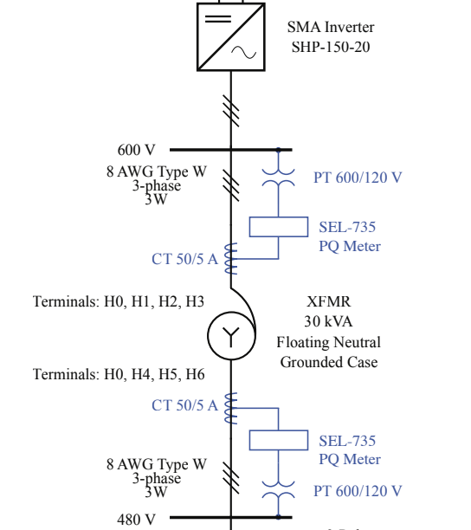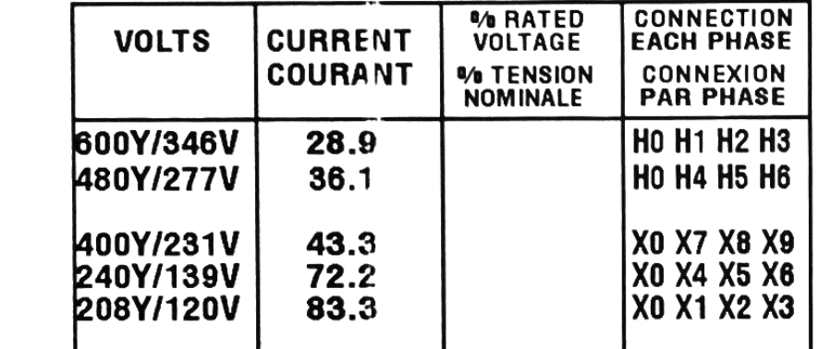

*Figure 26: Single Line Diagram & Transformer Specification*

When the experiment setup is running in bypass mode which means the inverter is directly connected to the power grid on the output side. The autotransformer needs to have 480Y(H4 H5 H6)on the low side connected to the grid. When we want to use the power amplifier to emulate the grid, we need to make sure the amplifier is connected to 240Y(X4 X5 X6). The status of the connection needs to be verified before energizing the system. If the autotransformer is misconfigured and the system is energized, the inverter and the DC power supply can be catastrophically damaged.

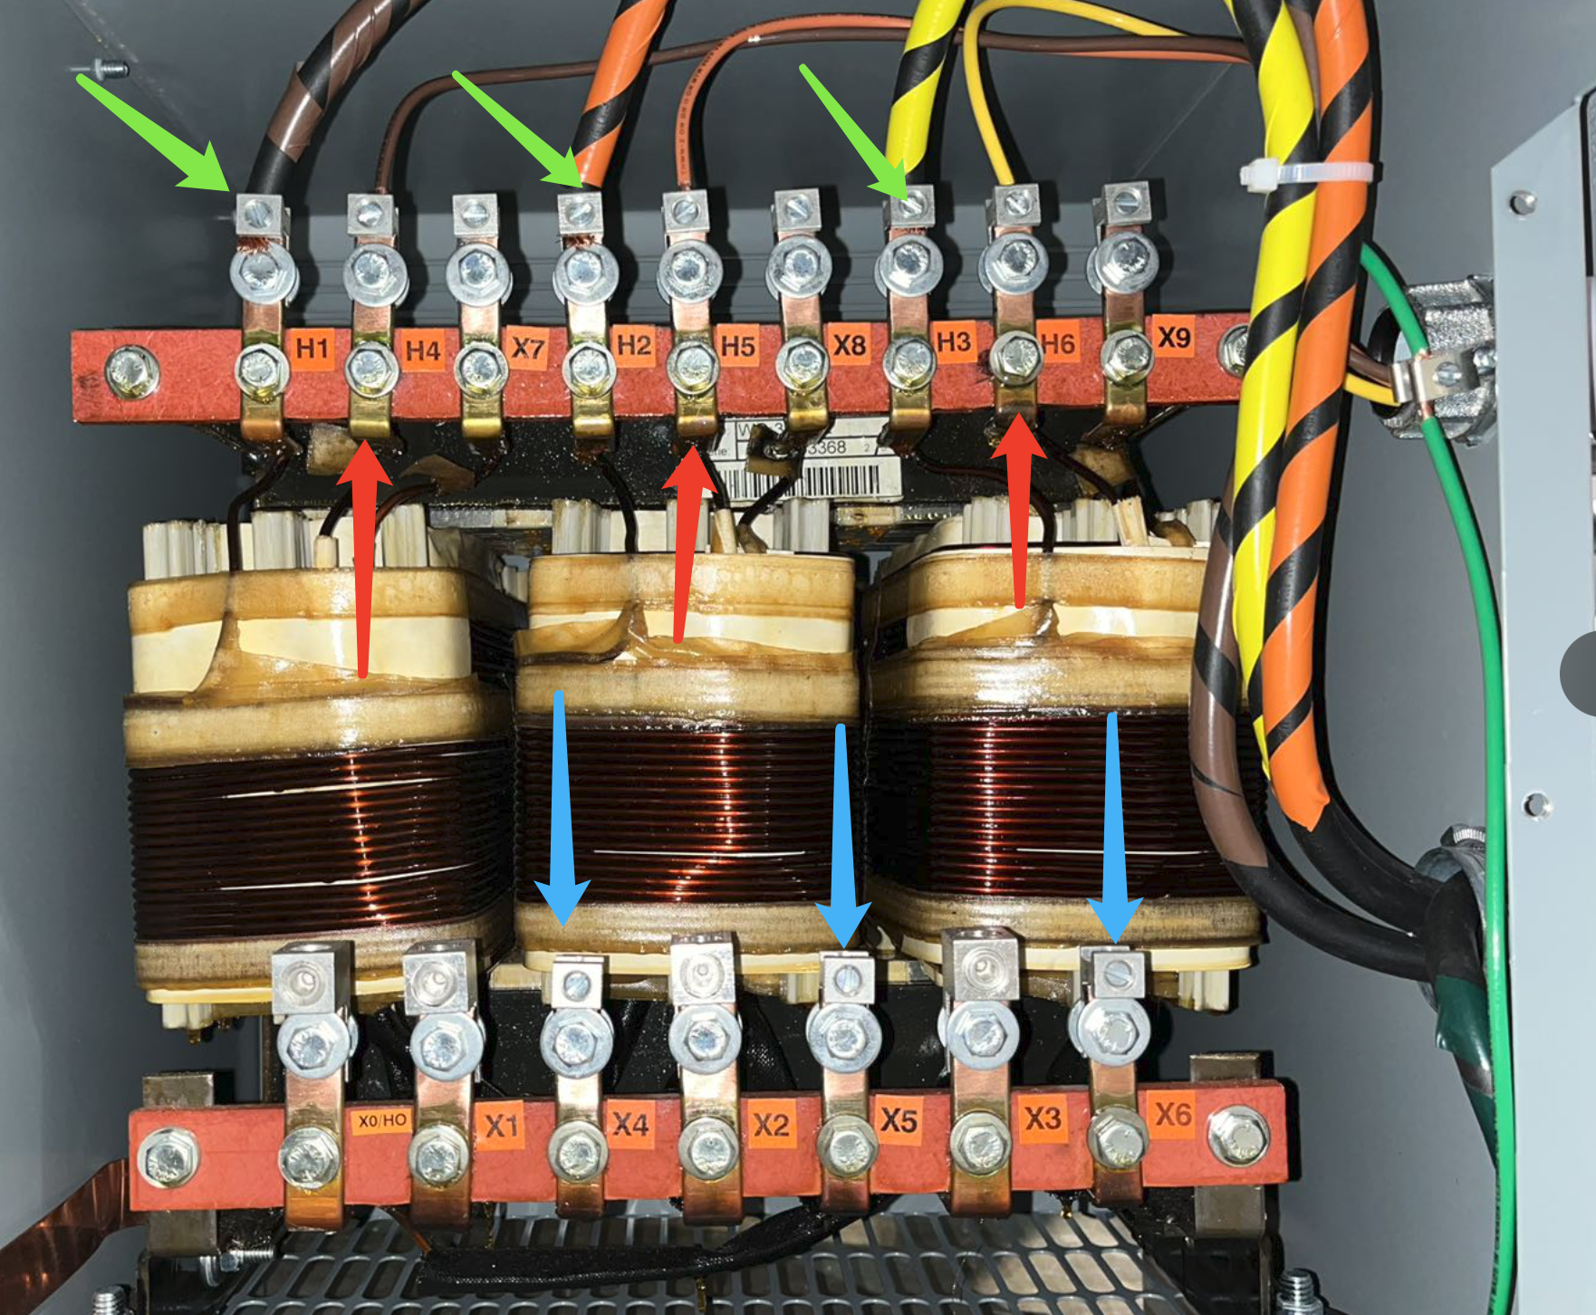

*Figure 27: Autotransformer*

From the above figure, we can see the inverter is connected to H1 H2 H3 terminals on the high side. The wires pointed by the red arrows are going to a 3-pole double throw switch as shown below. Since the maximum voltage of the power amplifier can’t reach 480V L-L, we need to change the transformer tabs as we change from power grid connection to power amplifier connection. Currently, the transformer is wired to be connected directly to power grid H4 H5 H6 which is indicated by the red arrow. Three blue arrows are pointing at X4 X5 X6 terminals which need to be connected to Opal-RT power amplifiers when grid emulation is implemented.

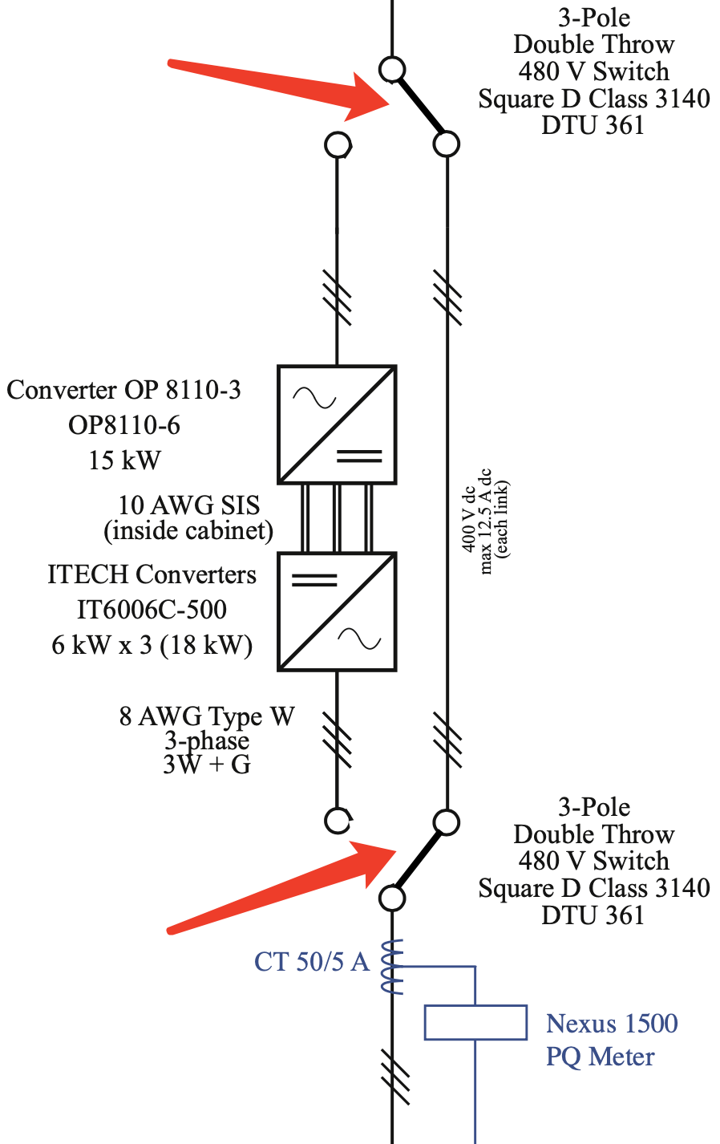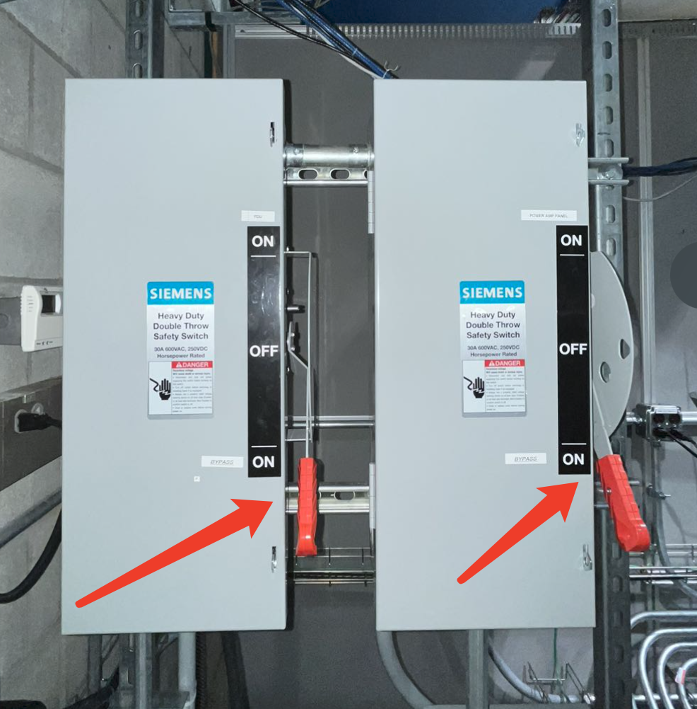

*Figure 26: Switch Box A*

We can control where the inverter is connected by switching the 3-pole double throw switches as shown in above figure and schematic. Currently the switches are configured in Bypass mode, which means the inverter is directly connected to a strong grid through the autotransformer.

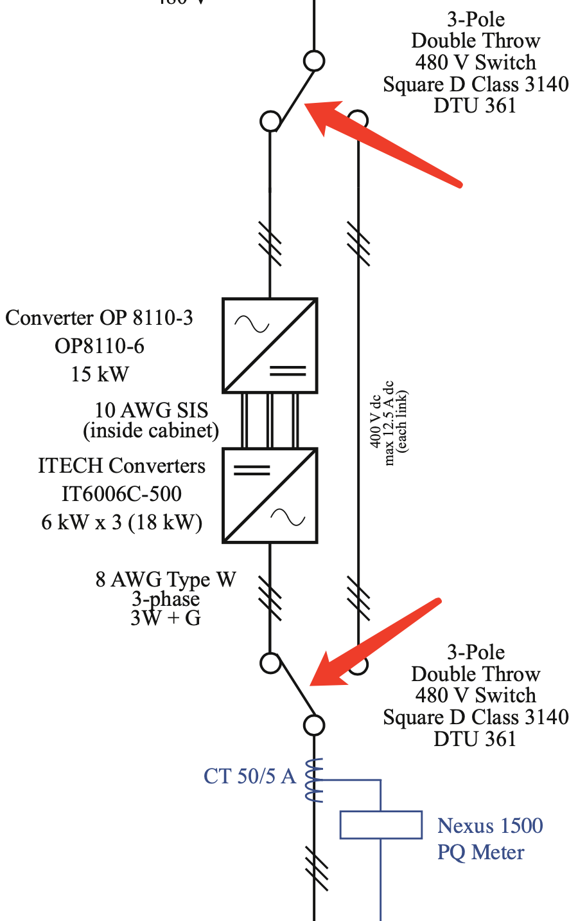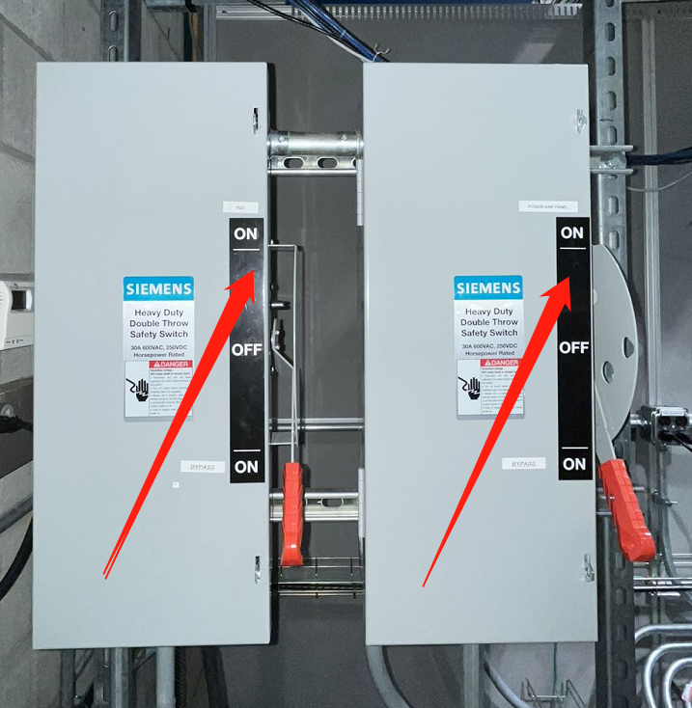

*Figure 27: Switch Box B*

The inverter is connected to the power amplifier as shown in above figure when both switch in up position(red arrow).

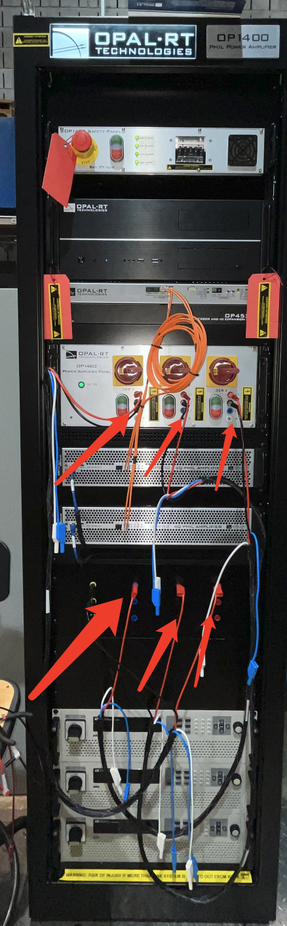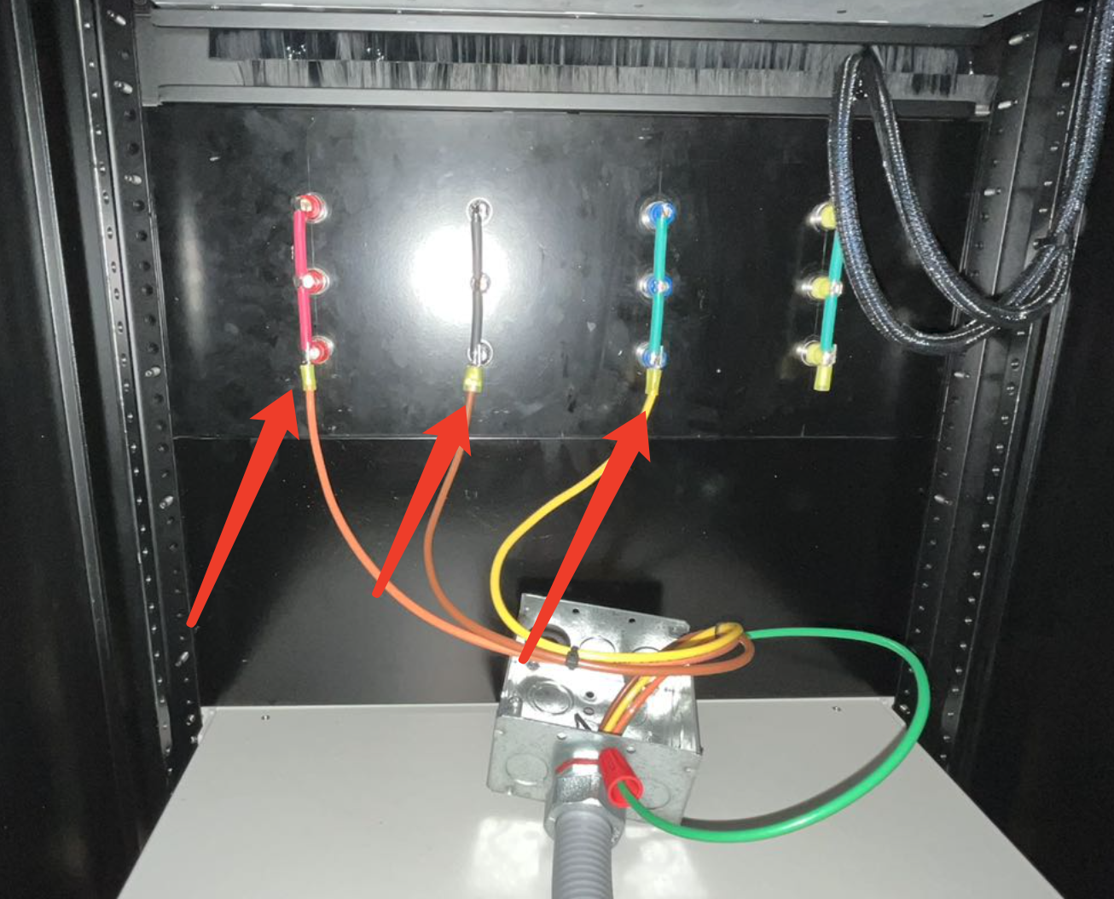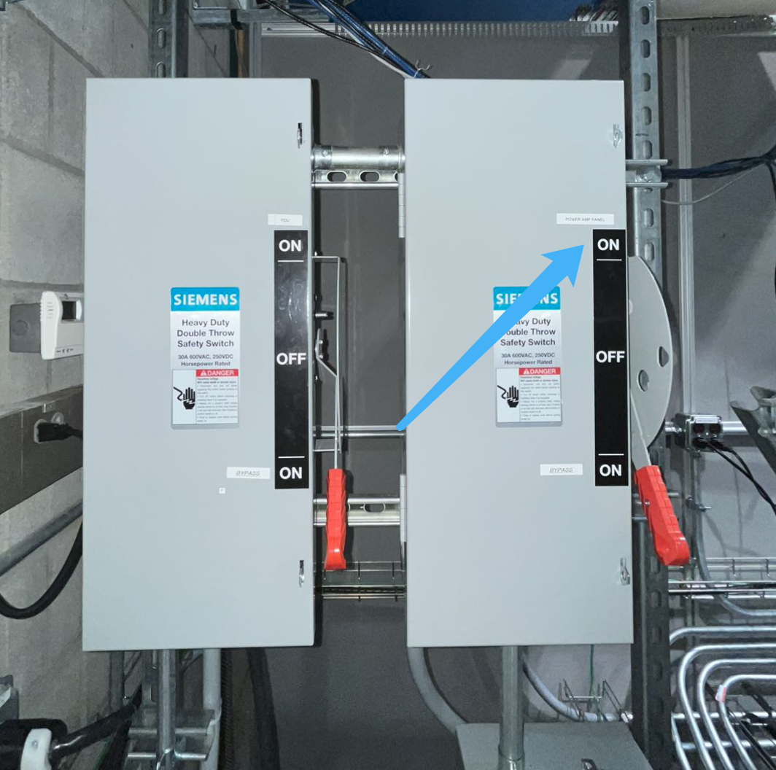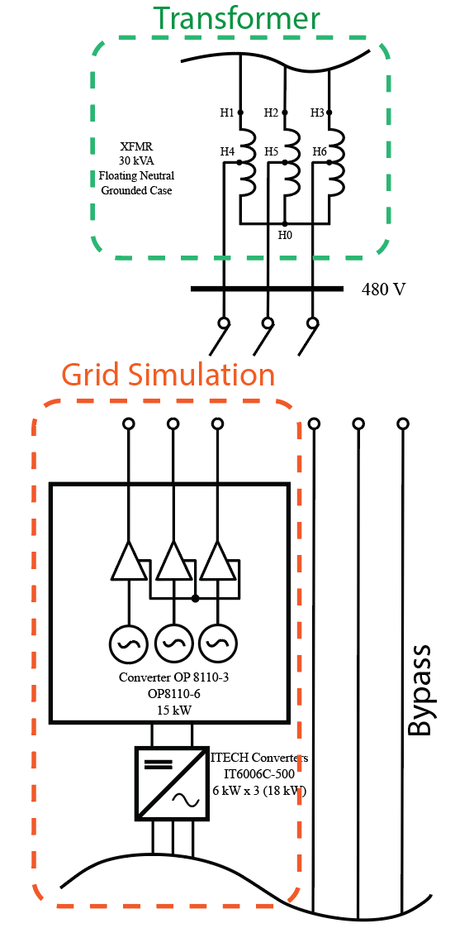

*Figure 28: Power Amplifier Configuration*

The 3 pole double throw switch on the right is connected to the front panel of the op1400 test bench. When we close the switch on the right(up where the blue arrow is pointing at), the test bench is connected to the autotransformer. On the figure on the right, the red arrow is indicating where the banana plug is located. We can easily change the wiring configuration and verify the voltage with a multimeter. The banana cables are connecting the DER to the Auto transformer. In our application, to maximize the performance of the power amplifier, the amplifier is configured in differential mode. Since the inverter doesn’t have a neutral connection, the amplifier and the inverter are wired in a floating neutral scheme.

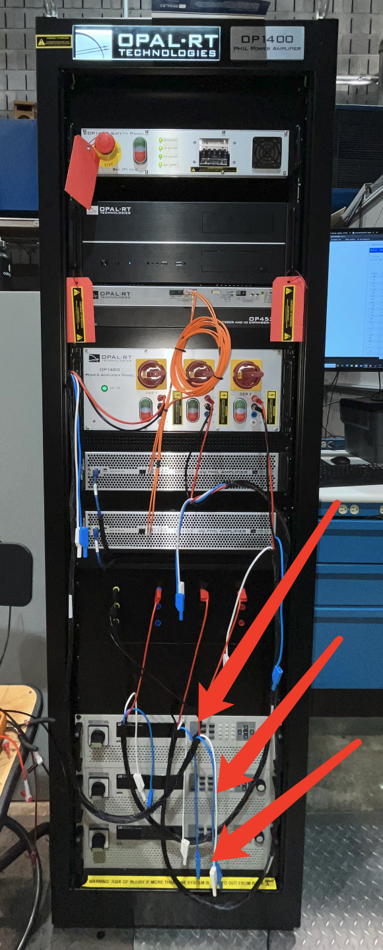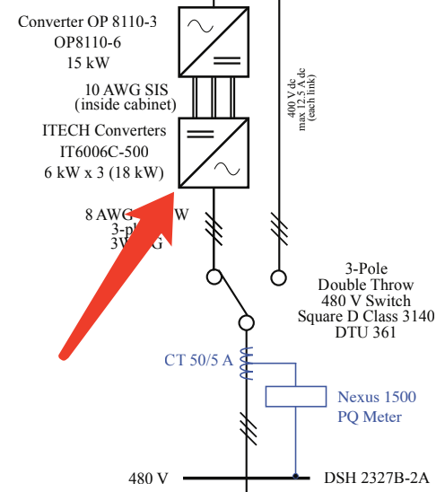



*Figure 29: Power Amplifier DC Power Source Configuration*

The power amplifier located at the bottom of the op1400(red arrow) is providing power or sinking power from the amplifier. Since the power supply is 4 quadrant, it’s able to regenerate real and reactive power into the power grid as the inverter generates real and reactive power.

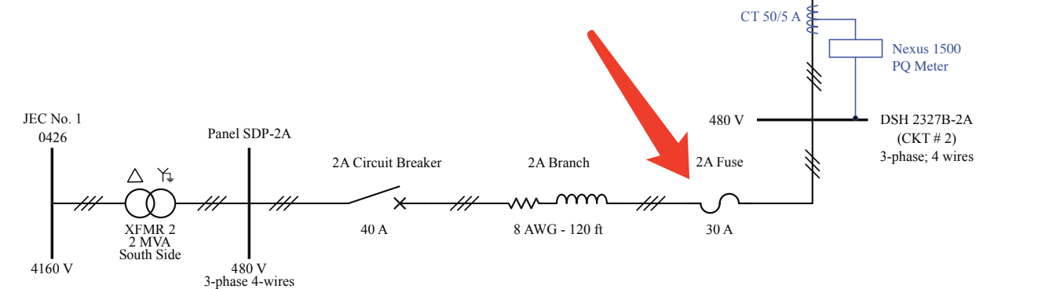

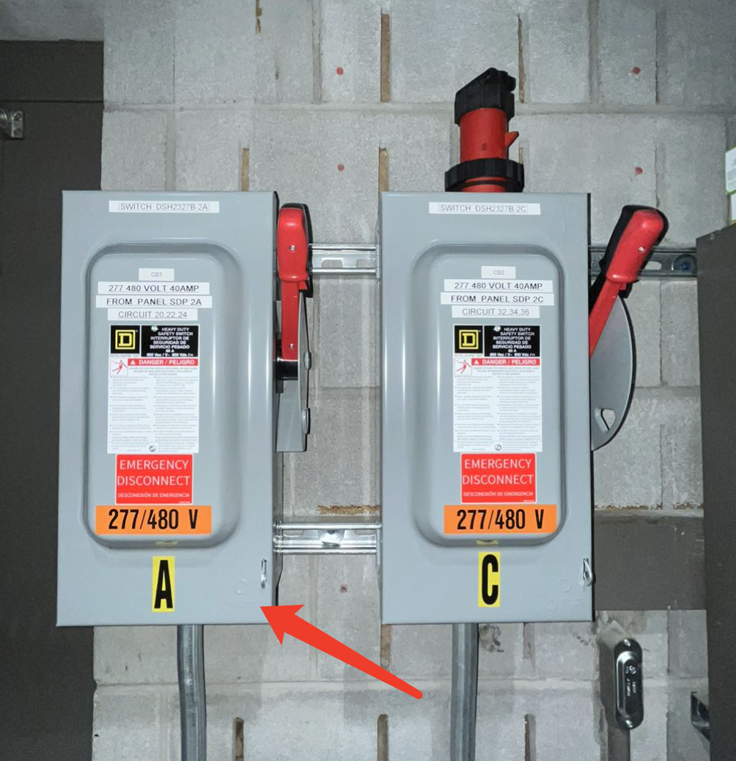

*Figure 30: Power Switch and Fuse Box*

For safe operation, a 40A circuit breaker is connected in the circuit to prevent any short fault to ground. The 30A fuse is protecting our DC power supply from extreme electrical failure to keep safe operation of all lab equipment. The switch A from above figure is located at where the 30A fuse is on the schematic.

## 

## Metering

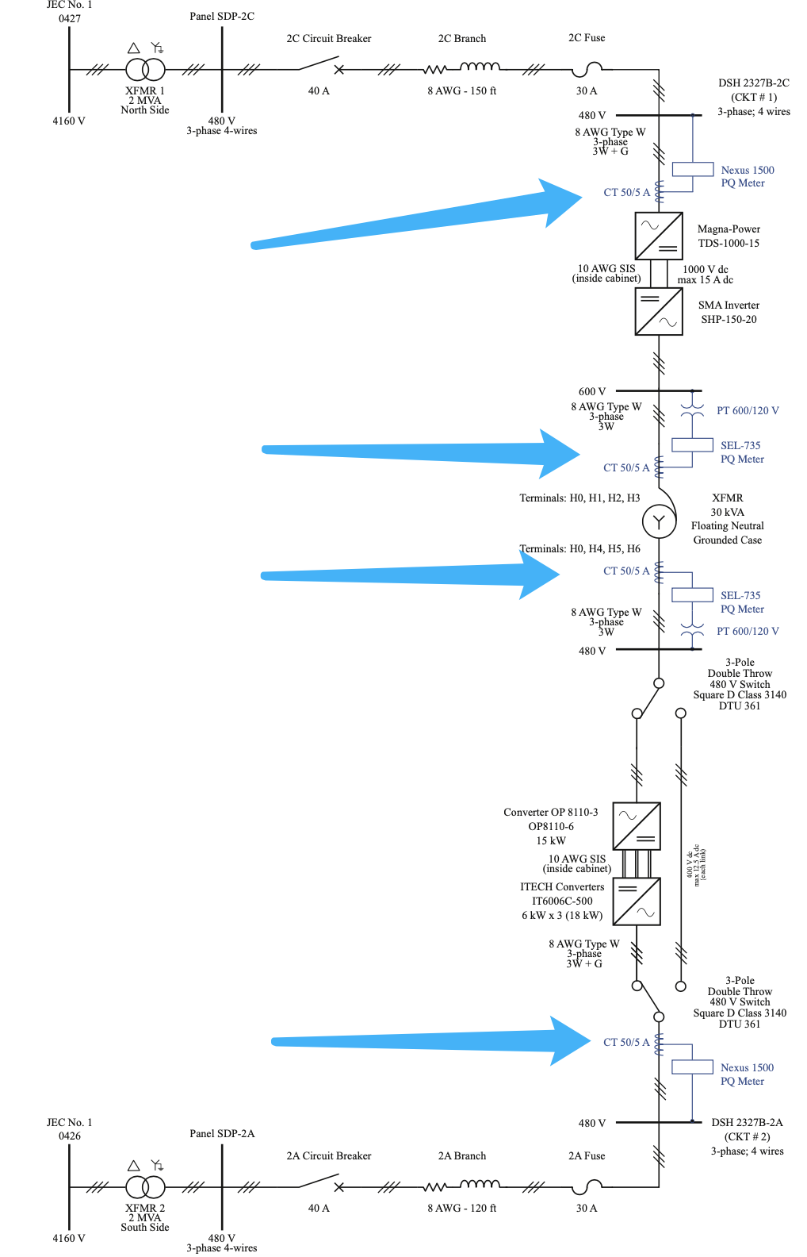

*Figure 31: Meters Location*

The above figure illustrates where the meters are located in this whole system.

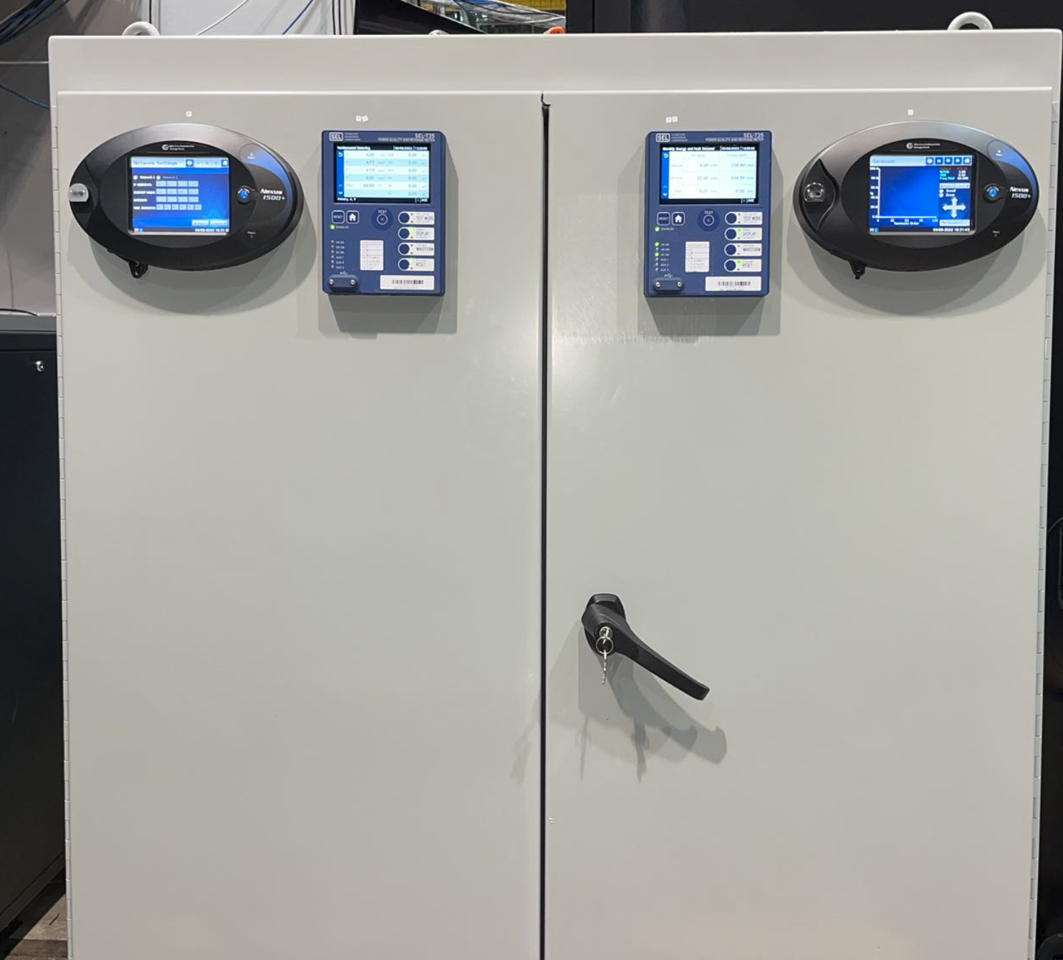

*Figure 32: Meters Cabinet*

The meters are located in an enclosed cabinet shown in the above figure.

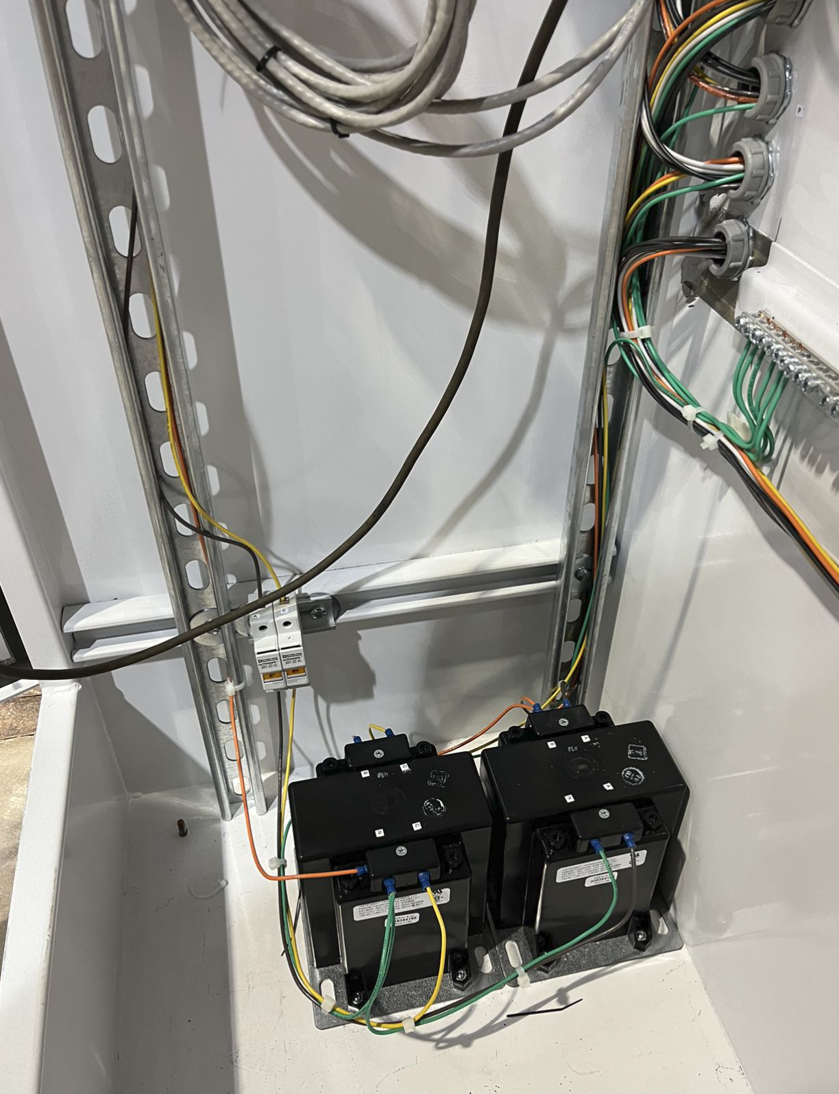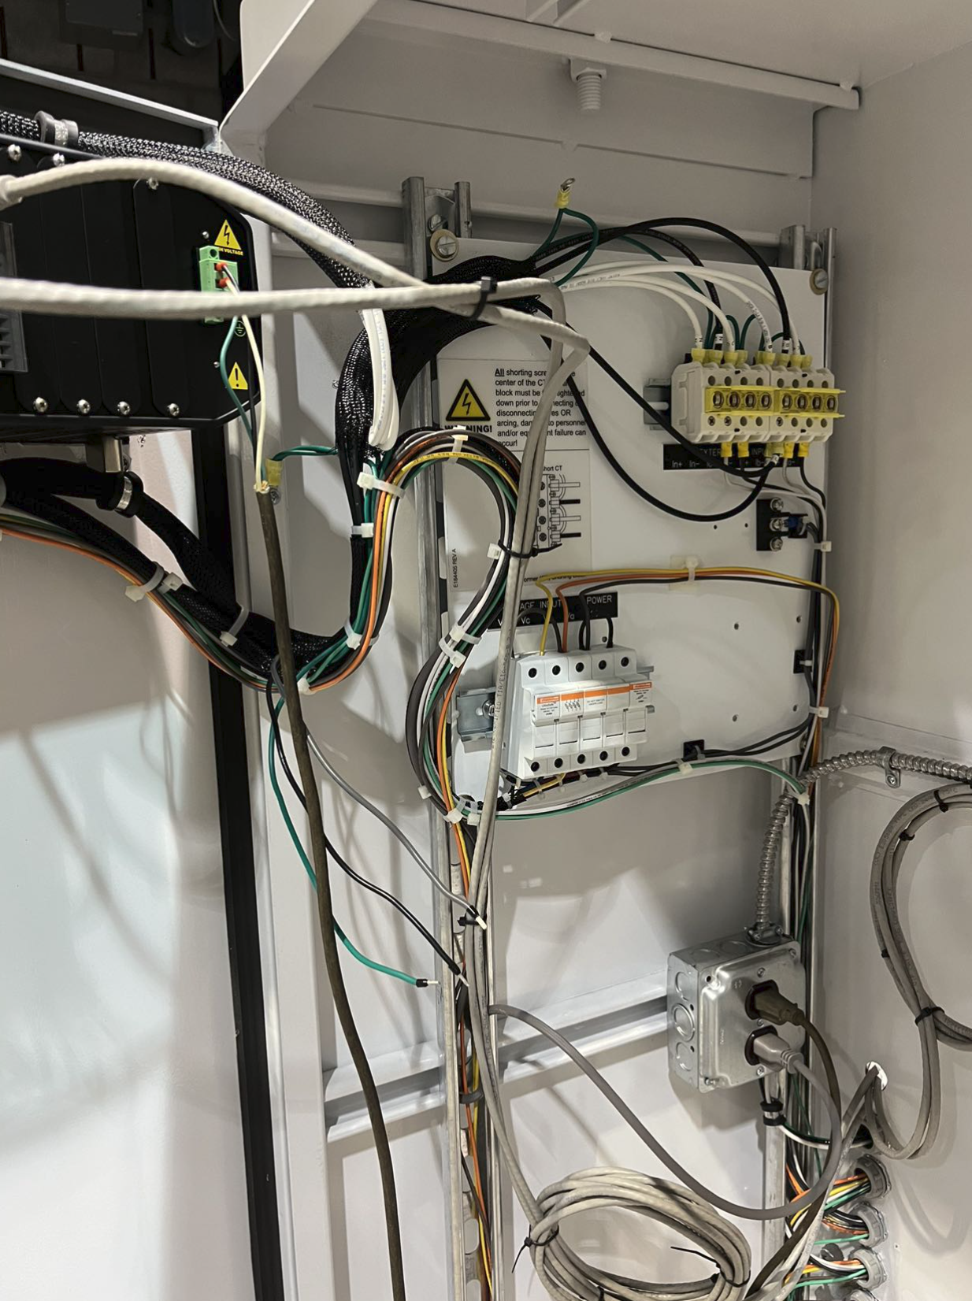

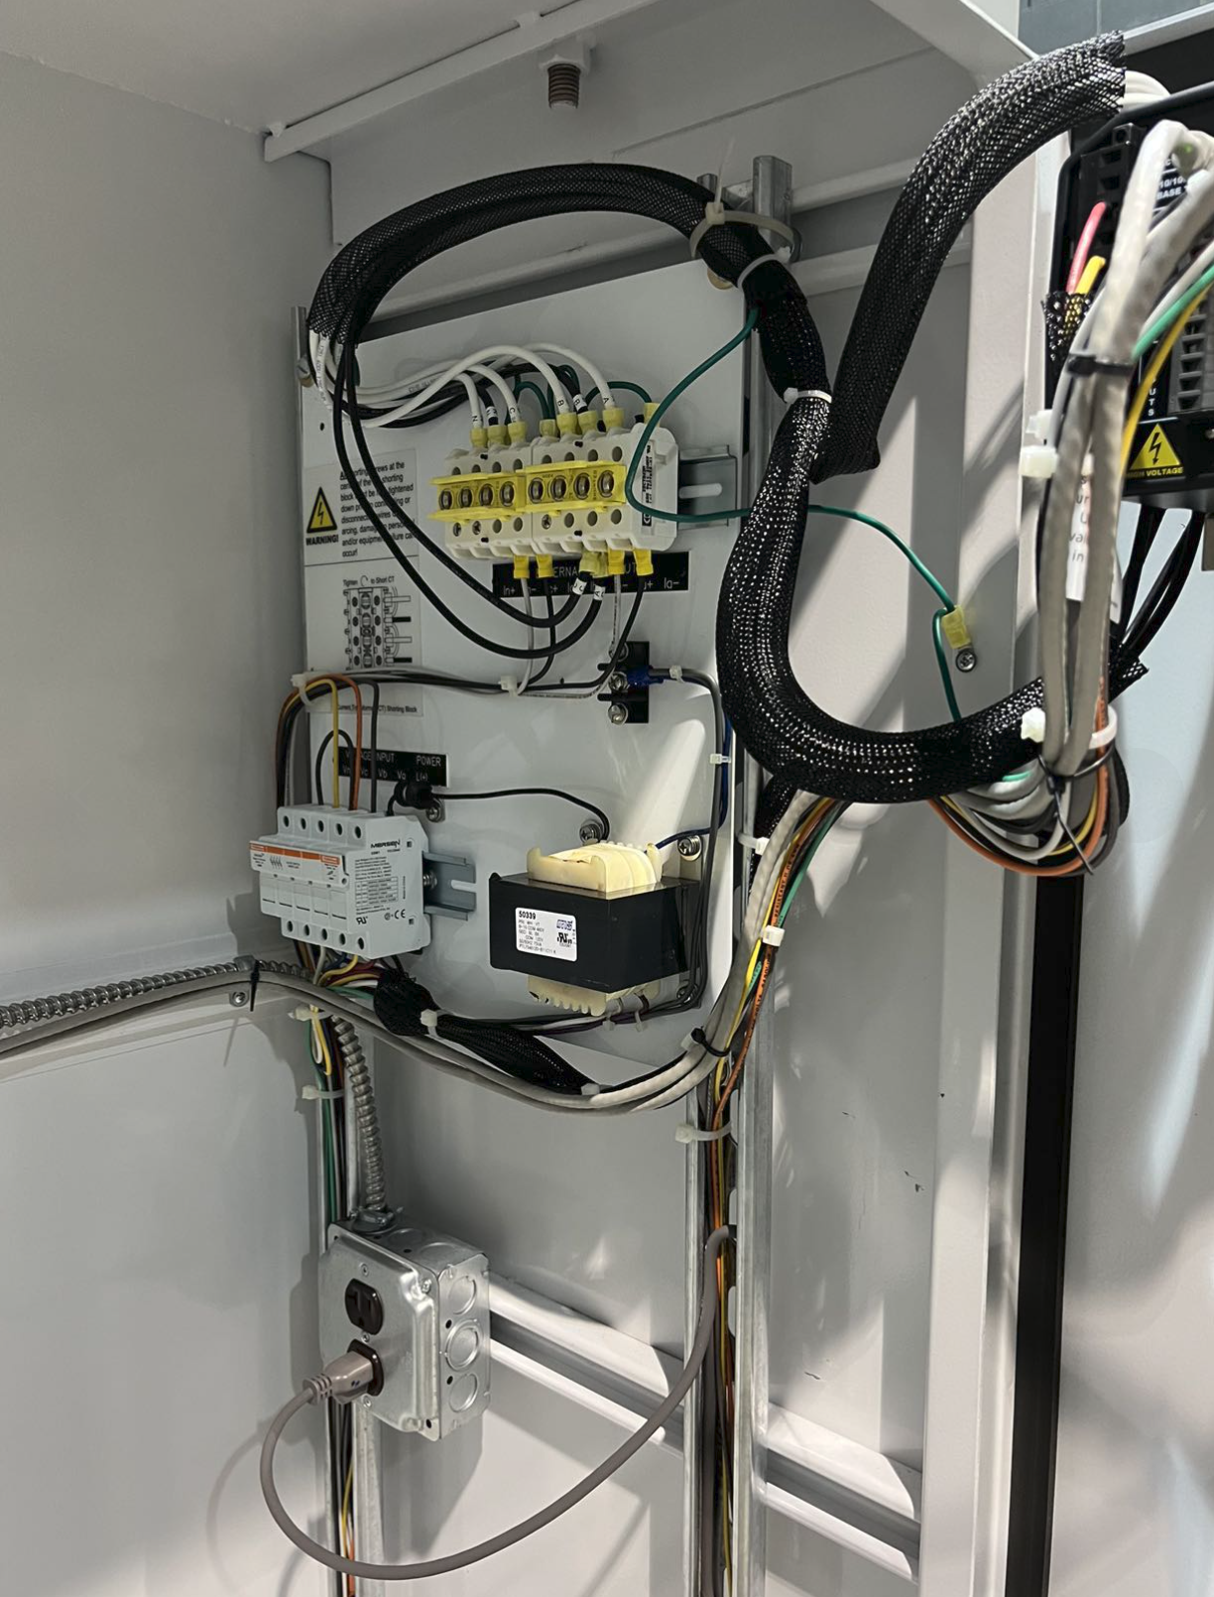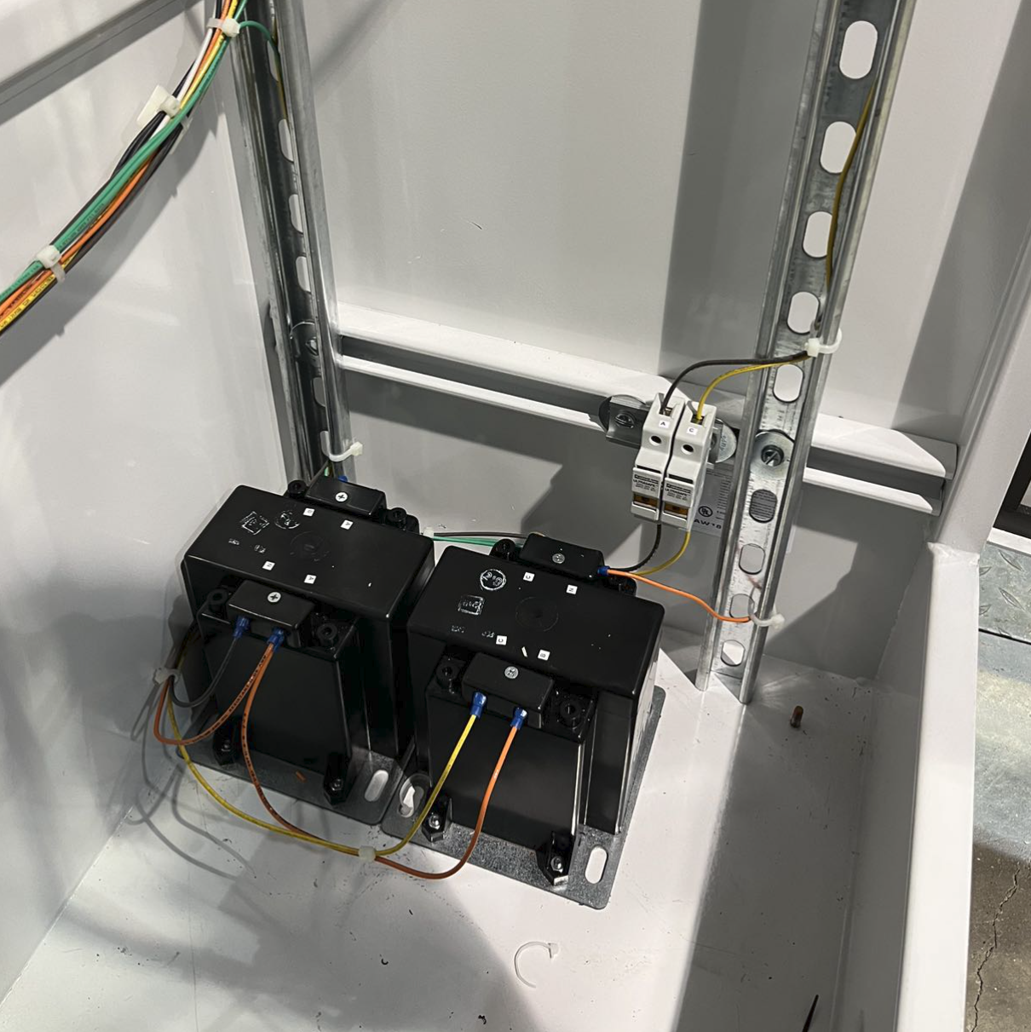

*Figure 31: Metering Equipments*

The above figures show the current transformer shunt and potential transformers for the metering inside the cabinet.

# Bibliography - References

[Cellier, F. E., & Greifeneder, J. (2013). *Continuous System Modeling*. Springer Science & Business Media.](http://paperpile.com/b/H2sNgl/f2MW)

[Korn, G. A., & Wait, J. V. (1978). *Digital continuous-system simulation*. Prentice-Hall.](http://paperpile.com/b/H2sNgl/Pm20)

[Laera, G., Vanfretti, L., Thomas, K., & Gardner, M. (2020). Object Oriented Modeling and Control Design for Power Electronics Half-Bridge Converter using Modelica. *American Modelica Conference*.](http://paperpile.com/b/H2sNgl/R29X)

<https://magna-power.com/assets/files/datasheets/datasheet_ts_4.5.0.pdf>

<https://wiki.opal-rt.com/display/SSDD/OP1400+PHIL+Test+Bench+Series+User+Manual>

https://www.maddoxtransformer.com/products/9a7c18da-cabc-55ee-ab6a-12cd1dc9dc84/?variant=31595353899091

# 

# Appendix

